
Course: CSE344-Semantic Web (with solutions)
(With Solutions)
List of practices/Lab Tasks



WEEK | Topics | Page no.
Week 1 & 2 | XML building and concept, DTD, Namespaces, URI | 3
Week 3&4 | XSD (XML Schema), XML Visualization, XPath | 7
Week 5 | XML Transformation (XSL) | 13
Week 6&7 | RDF and RDF file formation | 19
Week 8 | RDF Graph, RDFa | 29
Week 9 | RDF Schema (RDFS) | 39
Week 10 & 11 | Ontology building by using protégé, create classes, sub-classes, object type properties, data type properties, annotation Type properties, Setting of Domain, Range, URI, Prefixes, inverse, transitive and symmetric properties with OWL-RDF Language | 51
Week 12&13 | DL query using reasoning and Ontograf building using Protege | 88
Week 14&15 | SPARQL | 97

CSE 344 – Semantic Web Lab
Week1&2: XML building and concept, XSD (XML Schema)

Learning Objectives:
The objectives of this first experiment are:
- Expose the students to the XML family of technologies, and the latest W3C and WS-I XML standards.
- Students will learn about HTML coding tags and how XML makes tag in coding according to required elements.
- They should know about namespaces and prefixes used via XML coding.
- Concept of URI and binding of URI with prefixes and resolve conflicts with same elements.
- Students should have knowledge about DTD and code it.
- Demonstrate the use of XML to support the modern approach at building comprehensive business applications using XML Markup Language technologies, XML information modeling, XML information processing and XML application implementation and testing methodologies and tools.
Your lab report is expected to contain the following for each exercise:
- XML Source Code
Exercise 1:
Make an XML file name having books detail on notepad++ and check its validity.
Books.xml
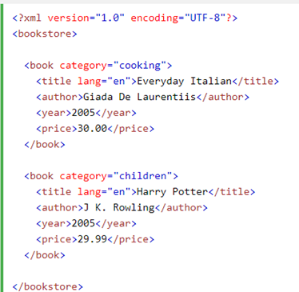

Exercise 2: Write an XML code showing the solution of Prefix conflict with same element.

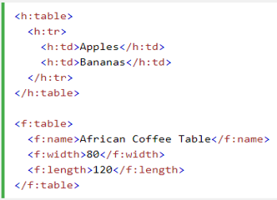

Exercise 3: Write an XML code with root node and the usage of namespace with associated prefixes.
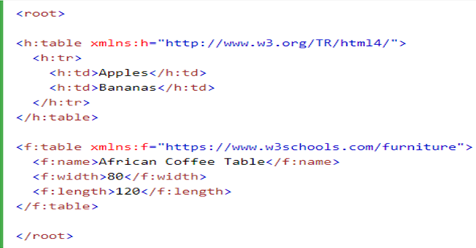

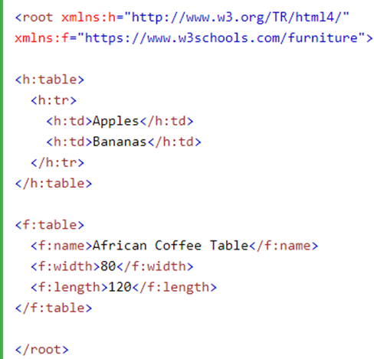

Exercise 4: Write an XML Program with DTD.

XML document with a Document Type Definition:
<?xml version=”1.0”?>
<!DOCTYPE note [
<!ELEMENT note (to,from,heading,body)>
<!ELEMENT to (#PCDATA)>
<!ELEMENT from (#PCDATA)>
<!ELEMENT heading (#PCDATA)>
<!ELEMENT body (#PCDATA)>
]>

<note>
<to>Ali</to>
<from>Asad</from>
<heading>Reminder</heading>
<body>We have meeting Today</body>
</note>

Another Example:
<?xml version = "1.0"?>
<!-- students2.xml for the DTD -->
<!DOCTYPE students SYSTEM "students.dtd">
<students>
<student>
<name>
<firstname> James </firstname>
<lastname> Smith </lastname>
</name>
<address>
<street> 101 South Street</street>
<city> Halifax </city>
<email> james@dal.ca </email>
<phone> 4940001 </phone>
</address>
</student>
<student>
<name>
<firstname> Tom </firstname>
<lastname> White </lastname>
</name>
<address>
<street> 202 Victoria Road </street>
<city> Dartmouth </city>
<email> tom@dal.ca</email>
<phone> 4940002 </phone>
</address>
</student>
</students>
<?xml version = "1.0"?>
<!--students.dtd-a document type definition for the students.xml-->
<!ELEMENT students (student+)>
<!ELEMENT student (name,address)>
<!ELEMENT name (firstname,lastname)>
<!ELEMENT firstname (#PCDATA)>
<!ELEMENT lastname (#PCDATA)>
<!ELEMENT address (street,city,email,phone)>
<!ELEMENT street (#PCDATA)>
<!ELEMENT city (#PCDATA)>
<!ELEMENT email (#PCDATA)>
<!ELEMENT lastname (#PCDATA)>
CSE 344 – Semantic Web Lab
Week 3&4: XSD (XML Schema), XML Visualization, XPath

Learning Objectives: The objectives of this experiment are:
- Students should make XML Schema, so they will aware about the structure of XML contents, elements, attributes, data objects etc
- Graphical structure representation in XML visualization format will clear the content of XML code and XSD schema by the help of https://codebeautify.org/xmlviewer.
- Check out the current XML Path expression and Validate XPath statement by the help of notepad++ from a large XML file. Students should have command to get results from multiple XPath statements. Check your solutions by https://www.freeformatter.com/xpath-tester.html
Your lab report is expected to contain the following for each exercise:
- XML Source Code
- XSD Code
- XPath Statements
- GUI Browser

Exercise 1: Write an XSD code with restrictions, simple and complex type elements, sequence, datatypes, enumerations, date, time, minOccurs and maxOccurs, translation from relational Table etc.

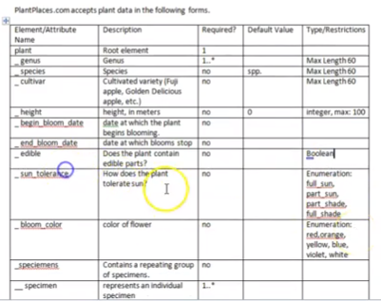
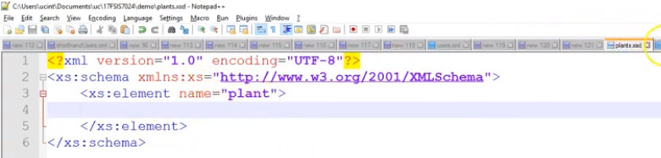
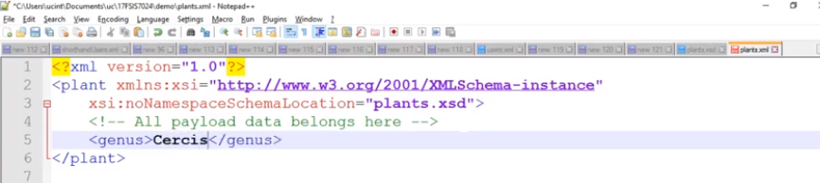
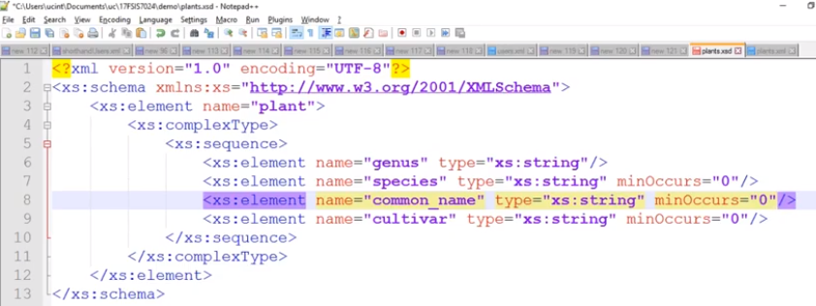
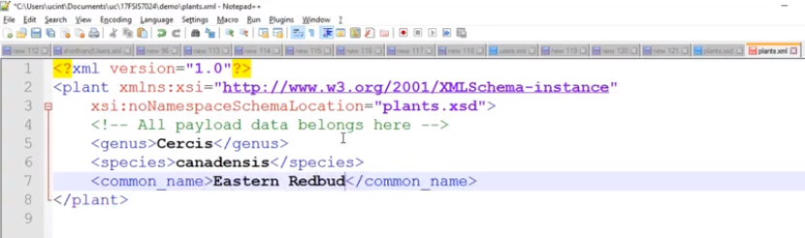
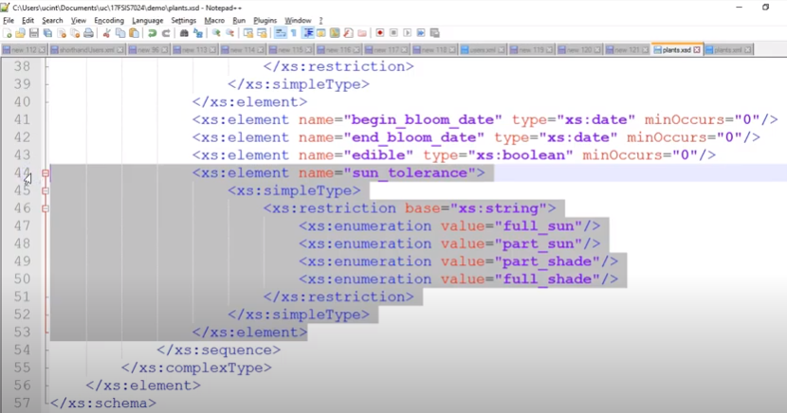
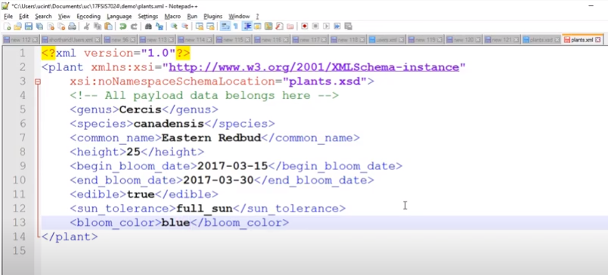

Exercise 2: Make XML Graph by using XML visualizer, XML file of shiporder and XML file of pizza. Firstly, apply format/beautify on both case studies XML files, then check out Tree view for the formatted XML file.

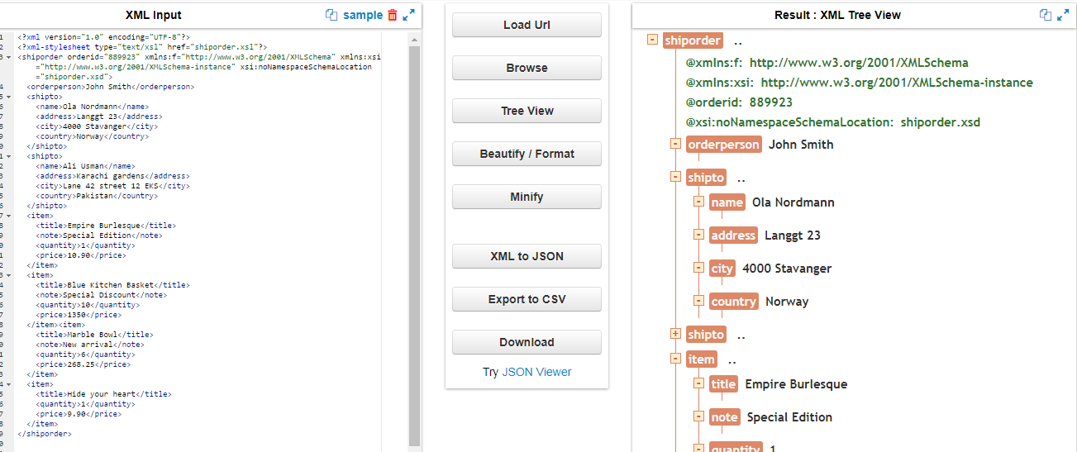

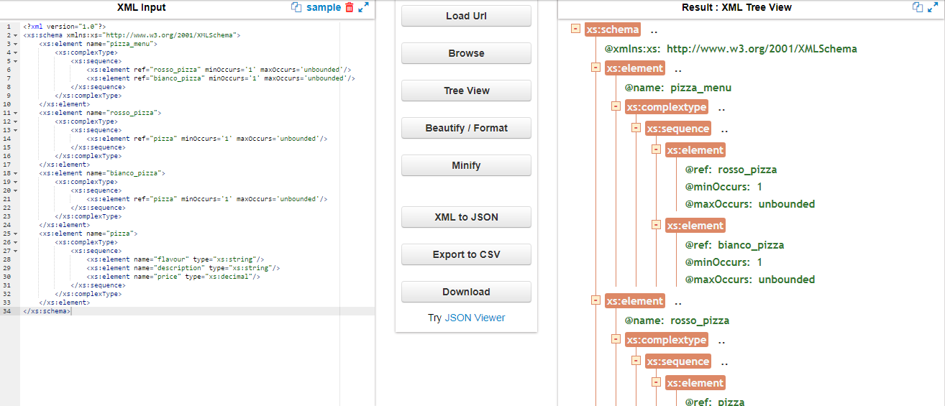

Exercise 3: Write XPath statements to find accurate data from long XML coding file. This XPath will use and transform in HTML or other XML files for display.

XPath Expression Evaluation in Notepad++

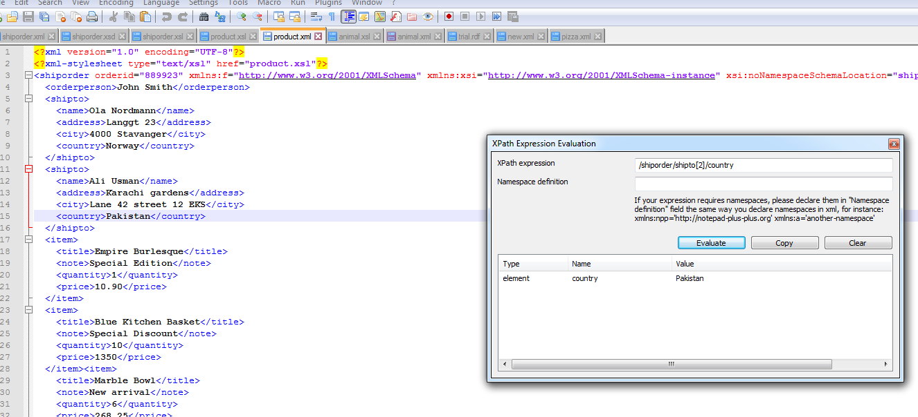

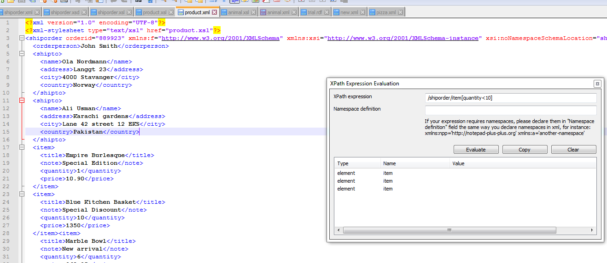

Output XPath Tester by https://www.freeformatter.com/xpath-tester.html

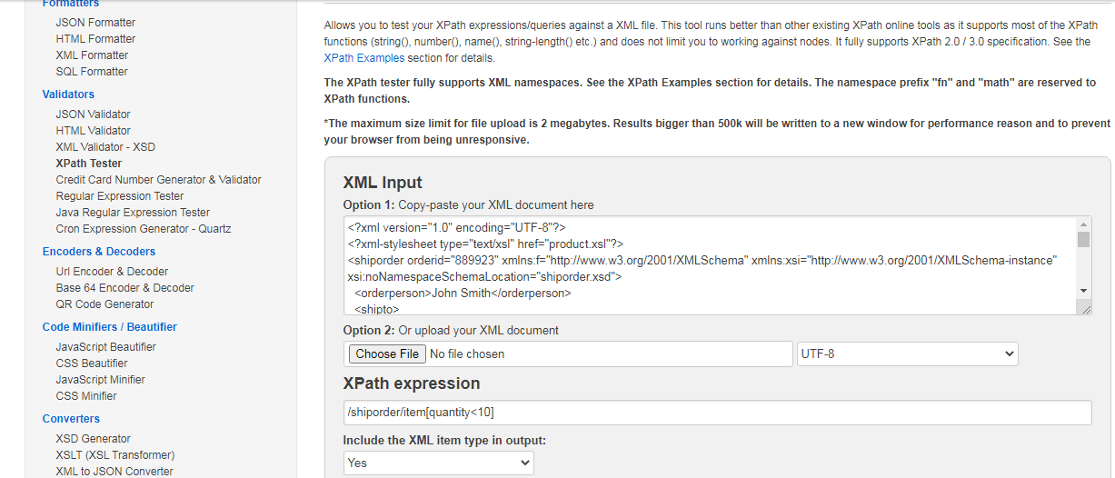

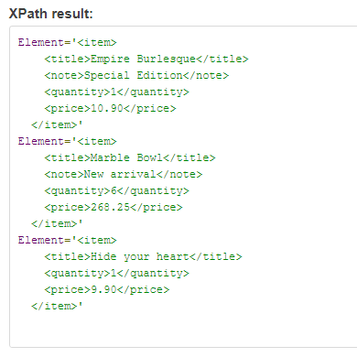

CSE 344 – Semantic Web Lab
Week 5: XML Transformation (XSL)

Learning Objectives: The objective of this exercise is to know how about XSLT (XML Transformation), students can transform HTML file/ XML updated file with visual representation of XML Schema. All the components of XML file can be viewed on HTML browser and some selected components can also be display on the HTML browser by the help of XPath and XQuery patterns.

Your lab report is expected to contain the following for each exercise:
- XML Source Code
- XSD Source Code
- XSL Source Code
- GUI Browser

Exercise 1:

Make an XSL file after creation of XML and XSD files. XSL file tags will be in HTML formatting. Run path of XML file on HTML Browser with XPath evaluation.

XML file

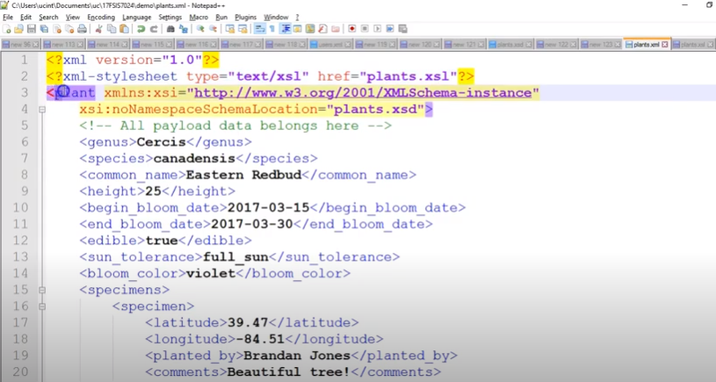

XSL File

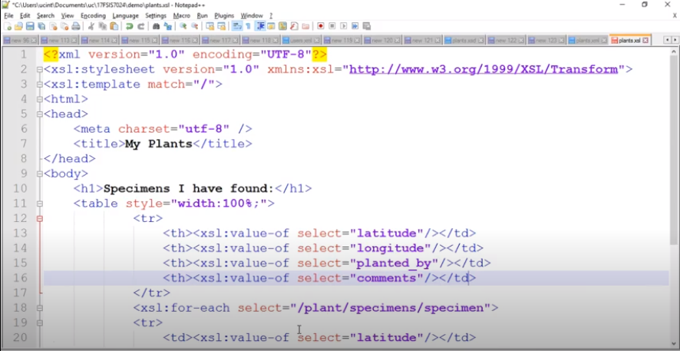

Copy file path to run on HTML browser

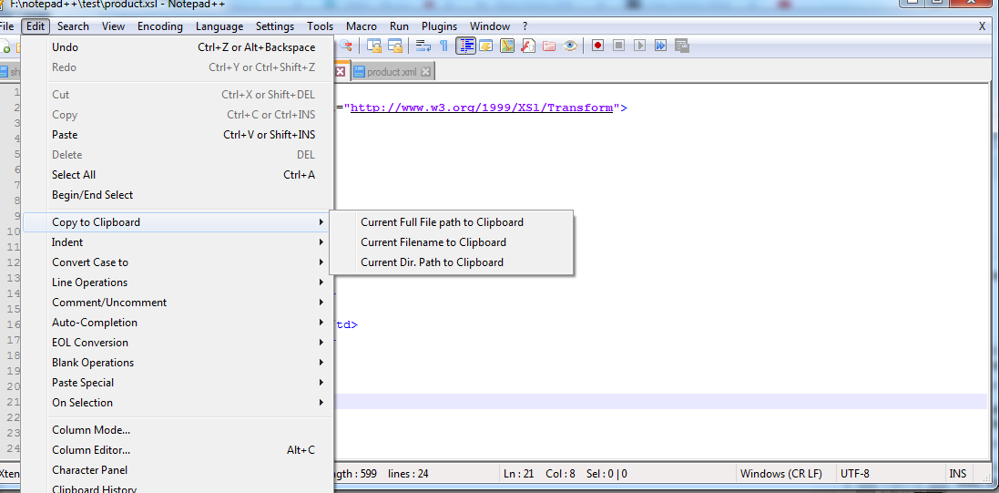

Output on GUI

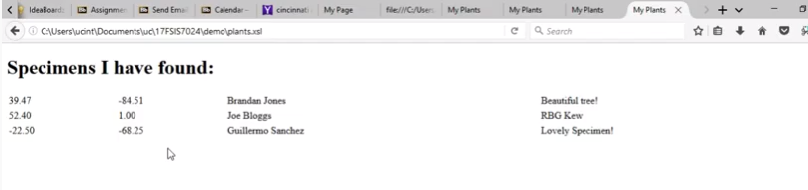

Exercise 2: Display result in HTML Browser after making given below files, whereas the case study is about shiporder, purchase items, store and product details.

- Create XML File
- Build Schema – XSD File
- Make XPath statements
- Create XSL File – XSLT (XML Transformation to HTML)
- Method call to XSD file and Link to XPath in XSL File

XML File = shiporder.xml
<?xml version="1.0" encoding="UTF-8"?>
<?xml-stylesheet type="text/xsl" href="shiporder.xsl"?>
<shiporder orderid="889923" xmlns:f="http://www.w3.org/2001/XMLSchema" xmlns:xsi="http://www.w3.org/2001/XMLSchema-instance" xsi:noNamespaceSchemaLocation="shiporder.xsd">
<orderperson>John Smith</orderperson>
<shipto>
<name>Ola Nordmann</name>
<address>Langgt 23</address>
<city>4000 Stavanger</city>
<country>Norway</country>
</shipto>
<shipto>
<name>Ali Usman</name>
<address>Karachi gardens</address>
<city>Lane 42 street 12 EKS</city>
<country>Pakistan</country>
</shipto>
<item>
<title>Empire Burlesque</title>
<note>Special Edition</note>
<quantity>1</quantity>
<price>10.90</price>
</item>
<item>
<title>Blue Kitchen Basket</title>
<note>Special Discount</note>
<quantity>10</quantity>
<price>1350</price>
</item><item>
<title>Marble Bowl</title>
<note>New arrival</note>
<quantity>6</quantity>
<price>268.25</price>
</item>
<item>
<title>Hide your heart</title>
<quantity>1</quantity>
<price>9.90</price>
</item>
</shiporder>

XSD File = shiporder.xsd
<?xml version="1.0" encoding="UTF-8" ?>
<xs:schema xmlns:xs="http://www.w3.org/2001/XMLSchema">

<!-- definition of simple elements -->
<xs:element name="orderperson" type="xs:string"/>
<xs:element name="name" type="xs:string"/>
<xs:element name="address" type="xs:string"/>
<xs:element name="city" type="xs:string"/>
<xs:element name="country" type="xs:string"/>
<xs:element name="title" type="xs:string"/>
<xs:element name="note" type="xs:string"/>
<xs:element name="quantity" type="xs:positiveInteger"/>
<xs:element name="price" type="xs:decimal"/>

<!-- definition of attributes -->
<xs:attribute name="orderid" type="xs:string"/>

<!-- definition of complex elements -->
<xs:element name="shipto">
<xs:complexType>
<xs:sequence>
<xs:element ref="name"/>
<xs:element ref="address"/>
<xs:element ref="city"/>
<xs:element ref="country"/>
</xs:sequence>
</xs:complexType>
</xs:element>

<xs:element name="item">
<xs:complexType>
<xs:sequence>
<xs:element ref="title"/>
<xs:element ref="note" minOccurs="0"/>
<xs:element ref="quantity"/>
<xs:element ref="price"/>
</xs:sequence>
</xs:complexType>
</xs:element>

<xs:element name="shiporder">
<xs:complexType>
<xs:sequence>
<xs:element ref="orderperson"/>
<xs:element ref="shipto"/>
<xs:element ref="item" maxOccurs="unbounded"/>
</xs:sequence>
<xs:attribute ref="orderid" use="required"/>
</xs:complexType>
</xs:element>
</xs:schema>
XSL File = shiporder.xsl
<?xml version="1.0" encoding="UTF-8"?>
<xsl:stylesheet version="1.0" xmlns:xsl="http://www.w3.org/1999/XSL/Transform">
<xsl:template match="/">
<html>
<head>
<meta charset="utf-8"/>
<title>Customer Details</title>
</head>
<body>
<h1>Customer Details are as follows:</h1>
<table style="width:150%;">
<tr>
<th>
<xsl:value-of select="address"/>
</th>
<th>
<xsl:value-of select="city"/>
</th>
<th>
<xsl:value-of select="country"/>
</th>
</tr>
<xsl:for-each select="/shiporder/item[price>10]">
<tr>
<td>
<xsl:value-of select="address"/>
</td>
<td>
<xsl:value-of select="city"/>
</td>
<td>
<xsl:value-of select="country"/>
</td>
</tr>
</xsl:for-each>
</table>
</body>
</html>
</xsl:template>
</xsl:stylesheet>

CSE 344 – Semantic Web Lab
Week 6&7: RDF and RDF file formation

Learning Objectives: The objectives of this experiment are:
- What RDF is and how it fundamentally differs from XML and relational databases
- What is meant by a “graph data model”
- How RDF is typically represented visually
- The importance of the URI, and the significance (or lack thereof) of identity “universality”
- Describe in basic terms what the semantic web is.
- Experience the paradigm-shift of storing information as a graph database, rather than a hierarchical or relational database.
- Understand that the semantic web of data is defined using Resource Description Framework (RDF).
- Understand the basic principles of RDF statements and how they can define data graphs.
Your lab report is expected to contain the following for each exercise:
- RDF Source Code
- https://www.w3.org/2015/03/ShExValidata/
- https://www.w3.org/RDF/Validator/
- GraphDB
- Altova
- http://rdfa.info/play/
- https://www.w3.org/2012/pyRdfa/Validator.html#distill_by_uri

Exercise 1: Make RDF file of the given graph.

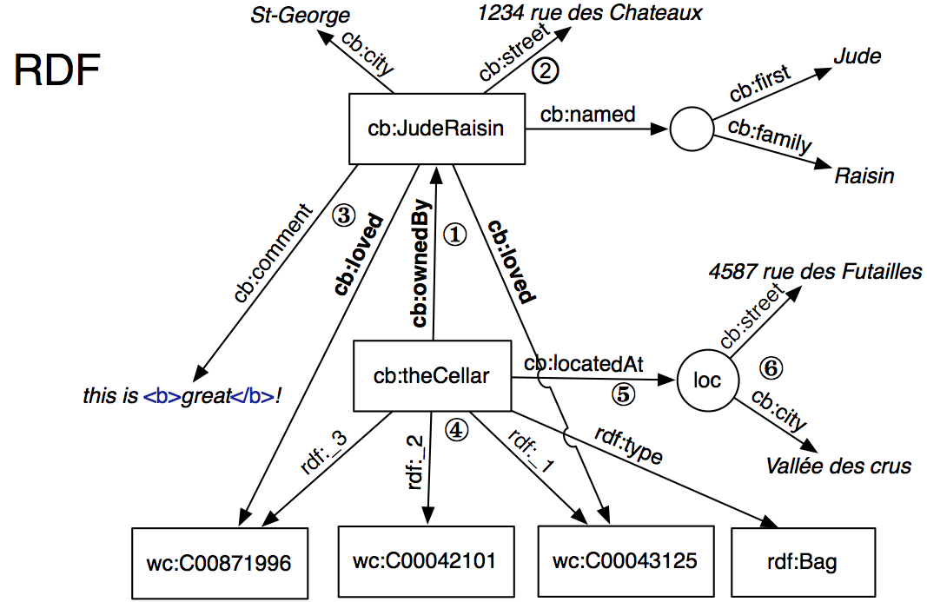

Solution:

1 <?xml version="1.0" encoding="UTF-8"?>
<?oxygen RNGSchema="rdfxml.rnc" type="compact"?>
<!DOCTYPE RDF [
<!ENTITY wc "http://www.iro.umontreal.ca/lapalme/WineCatalog#" >
5 <!ENTITY cb "http://www.iro.umontreal.ca/lapalme/CellarBook" >
]>
<rdf:RDF xmlns:rdf="http://www.w3.org/1999/02/22-rdf-syntax-ns#"
xmlns:rdfs="http://www.w3.org/2000/01/rdf-schema#"
xmlns:wc="&wc;"
10 xmlns:cb="&cb;#"
xml:base="&cb;">

<rdf:Description
rdf:about="http://www.iro.umontreal.ca/lapalme/CellarBook#theCellar">
15 <cb:ownedBy> <!-- 1 -->
<rdf:Description rdf:about="&cb;#JudeRaisin"/>
</cb:ownedBy>
</rdf:Description>

20 <rdf:Description
rdf:about="http://www.iro.umontreal.ca/lapalme/CellarBook#JudeRaisin"
cb:street="1234 rue des Châteaux" cb:city="St-George">
<cb:named rdf:parseType="Resource"> <!-- 2 -->
<cb:first>Jude</cb:first>
25 <cb:family>Raisin</cb:family>
</cb:named>
</rdf:Description>

<rdf:Description rdf:about="#JudeRaisin"><!-- 3 -->
30 <cb:loved rdf:resource="&wc;C00043125"/>
<cb:loved rdf:resource="&wc;C00871996"/>
<cb:comment rdf:parseType="Literal">this is <b>great</b>!</cb:comment>
</rdf:Description>

35 <rdf:Bag rdf:ID="theCellar"> <!-- 4 -->
<rdf:li rdf:resource="&wc;C00043125"/>
<rdf:li rdf:resource="&wc;C00042101"/>
<rdf:li rdf:resource="&wc;C00871996"/>
</rdf:Bag>
40
<rdf:Description rdf:about="#theCellar"><!-- 5 -->
<cb:locatedAt rdf:nodeID="loc"/>
</rdf:Description>

45 <rdf:Description rdf:nodeID="loc"> <!-- 6 -->
<cb:street>4587 des Futailles</cb:street>
<cb:city>Vallée des crus</cb:city>
</rdf:Description>

50
<!-- Schema definition -->

<!-- Classes -->
<rdfs:Class rdf:ID="Person"/> <!-- 7 -->
55 <rdfs:Class rdf:ID="Cellar"/>
<rdfs:Class rdf:ID="Wine"/>

<!-- Properties -->
<rdf:Property rdf:ID="loved"> <!-- 8 -->
60 <rdfs:domain rdf:resource="#Person"/>
<rdfs:range rdf:resource="#Wine"/>
</rdf:Property>

<rdf:Property rdf:ID="ownedBy"> <!-- 9 -->
65 <rdfs:domain rdf:resource="#Cellar"/>
<rdfs:range rdf:resource="#Person"/>
</rdf:Property>

</rdf:RDF>

Exercise 2: Make RDF file having book publisher’s detail.

Solution:

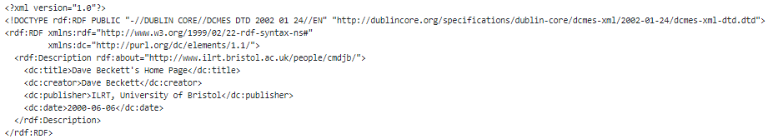

Exercise 3: Excerpt of CellarBook.xml, the XML instance document holding the content of the cellar, translate the give xml file to rdf file by identify Subject, Predicate and Object triples for the cellar book in RDF/XML.
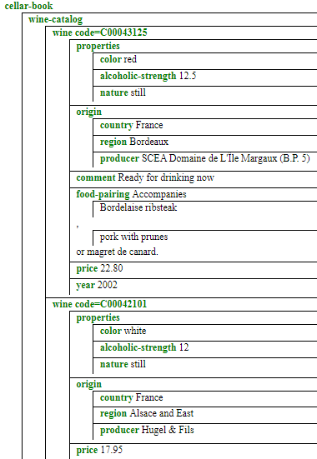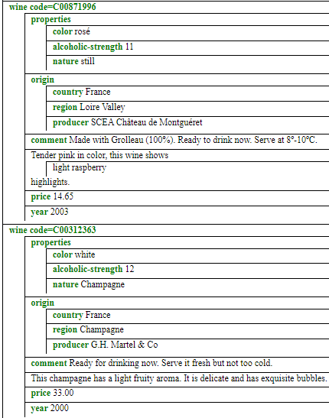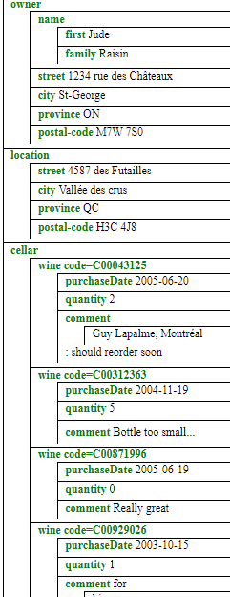

Solution:

1 <?xml version="1.0" encoding="UTF-8"?>
<?oxygen RNGSchema="rdfxml.rnc" type="compact"?>
<!DOCTYPE RDF [
<!ENTITY wc "http://www.iro.umontreal.ca/lapalme/WineCatalog#" >
5 <!ENTITY cb "http://www.iro.umontreal.ca/lapalme/CellarBook" >
]>
<rdf:RDF xmlns:rdf="http://www.w3.org/1999/02/22-rdf-syntax-ns#"
xmlns:rdfs="http://www.w3.org/2000/01/rdf-schema#"
xmlns:wc="&wc;"
10 xmlns:cb="&cb;#"
xml:base="&cb;">

<rdf:Description
rdf:about="http://www.iro.umontreal.ca/lapalme/CellarBook#theCellar">
15 <cb:ownedBy> <!-- 1 -->
<rdf:Description rdf:about="&cb;#JudeRaisin"/>
</cb:ownedBy>
</rdf:Description>

20 <rdf:Description
rdf:about="http://www.iro.umontreal.ca/lapalme/CellarBook#JudeRaisin"
cb:street="1234 rue des Châteaux" cb:city="St-George">
<cb:named rdf:parseType="Resource"> <!-- 2 -->
<cb:first>Jude</cb:first>
25 <cb:family>Raisin</cb:family>
</cb:named>
</rdf:Description>

<rdf:Description rdf:about="#JudeRaisin"><!-- 3 -->
30 <cb:loved rdf:resource="&wc;C00043125"/>
<cb:loved rdf:resource="&wc;C00871996"/>
<cb:comment rdf:parseType="Literal">this is <b>great</b>!</cb:comment>
</rdf:Description>

35 <rdf:Bag rdf:ID="theCellar"> <!-- 4 -->
<rdf:li rdf:resource="&wc;C00043125"/>
<rdf:li rdf:resource="&wc;C00042101"/>
<rdf:li rdf:resource="&wc;C00871996"/>
</rdf:Bag>
40
<rdf:Description rdf:about="#theCellar"><!-- 5 -->
<cb:locatedAt rdf:nodeID="loc"/>
</rdf:Description>

45 <rdf:Description rdf:nodeID="loc"> <!-- 6 -->
<cb:street>4587 des Futailles</cb:street>
<cb:city>Vallée des crus</cb:city>
</rdf:Description>

50
<!-- Schema definition -->

<!-- Classes -->
<rdfs:Class rdf:ID="Person"/> <!-- 7 -->
55 <rdfs:Class rdf:ID="Cellar"/>
<rdfs:Class rdf:ID="Wine"/>

<!-- Properties -->
<rdf:Property rdf:ID="loved"> <!-- 8 -->
60 <rdfs:domain rdf:resource="#Person"/>
<rdfs:range rdf:resource="#Wine"/>
</rdf:Property>

<rdf:Property rdf:ID="ownedBy"> <!-- 9 -->
65 <rdfs:domain rdf:resource="#Cellar"/>
<rdfs:range rdf:resource="#Person"/>
</rdf:Property>

</rdf:RDF>

Exercise 4: Write RDF file for the given graph.

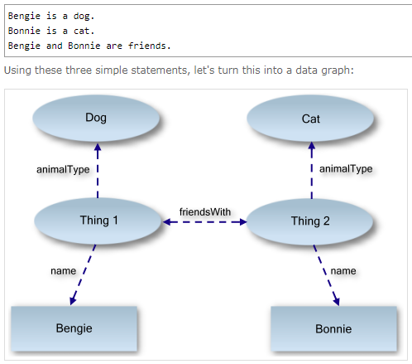

Solution:

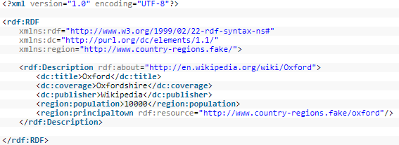

CSE 344 – Semantic Web Lab
Week 8: RDF Graph, RDFa

Learning Objectives: The objectives of this experiment are:
- What RDF is and how it fundamentally differs from XML and relational databases
- What is meant by a “graph data model”
- How RDF is typically represented visually
- The importance of the URI, and the significance (or lack thereof) of identity “universality”
- Describe in basic terms what the semantic web is.
- Experience the paradigm-shift of storing information as a graph database, rather than a hierarchical or relational database.
- Understand that the semantic web of data is defined using Resource Description Framework (RDF).
- Understand the basic principles of RDF statements and how they can define data graphs.
Your lab report is expected to contain the following for each exercise:
- RDF Source Code
- https://www.w3.org/2015/03/ShExValidata/
- https://www.w3.org/RDF/Validator/
- GraphDB
- Altova
- http://rdfa.info/play/
- https://www.w3.org/2012/pyRdfa/Validator.html#distill_by_uri

Exercise 1: Make RDF file of the given graph.

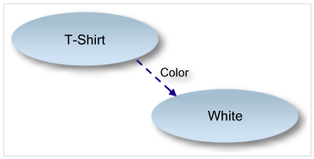

Solution:

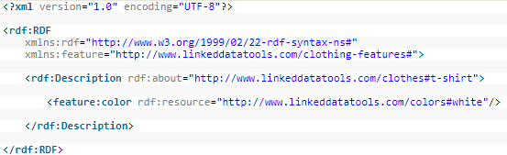

Exercise 2: Generate RDF file of your assigned task (selected by individual student in XML case – XML, XML DTD, XSL, XSLT). Use https://www.w3.org/RDF/Validator/ to Validate and show results in triple and Graph format.

Solution

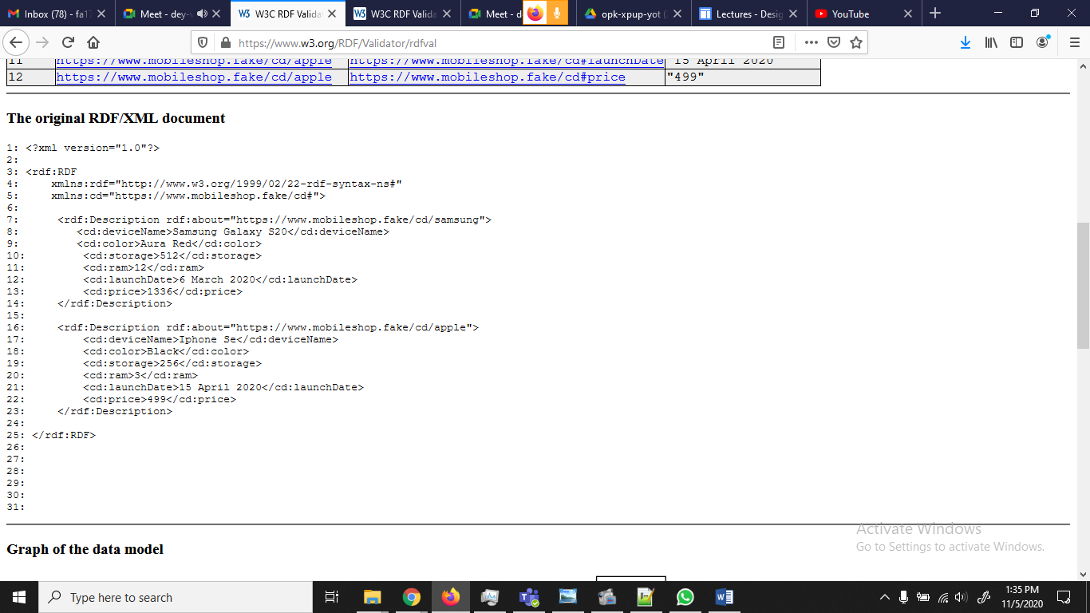

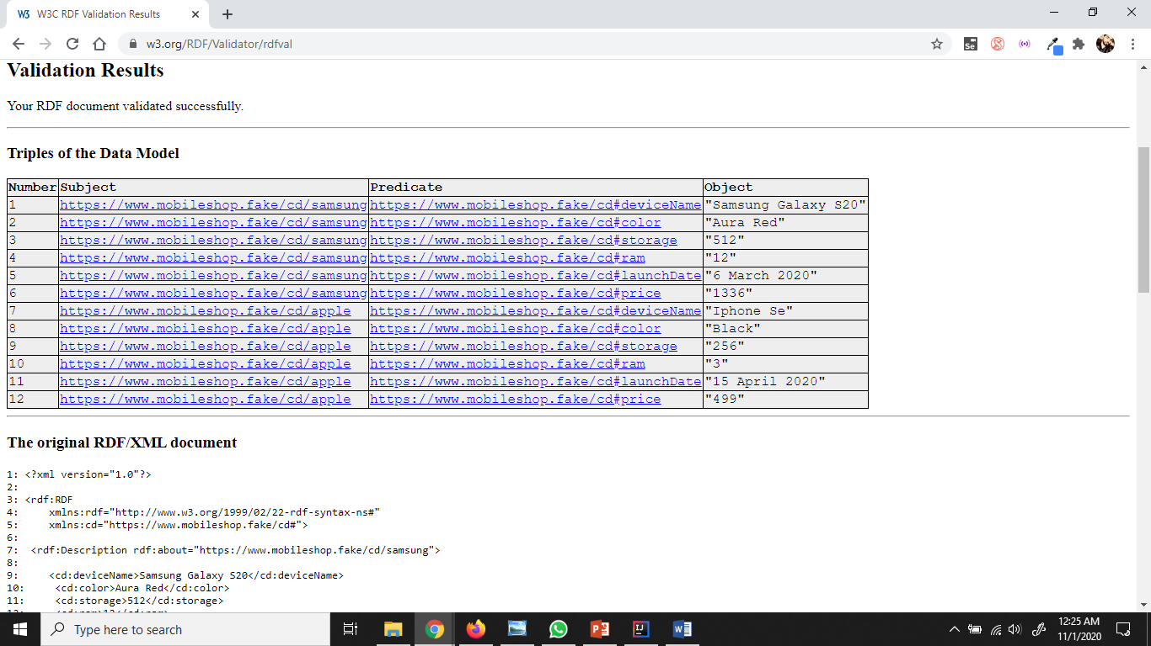

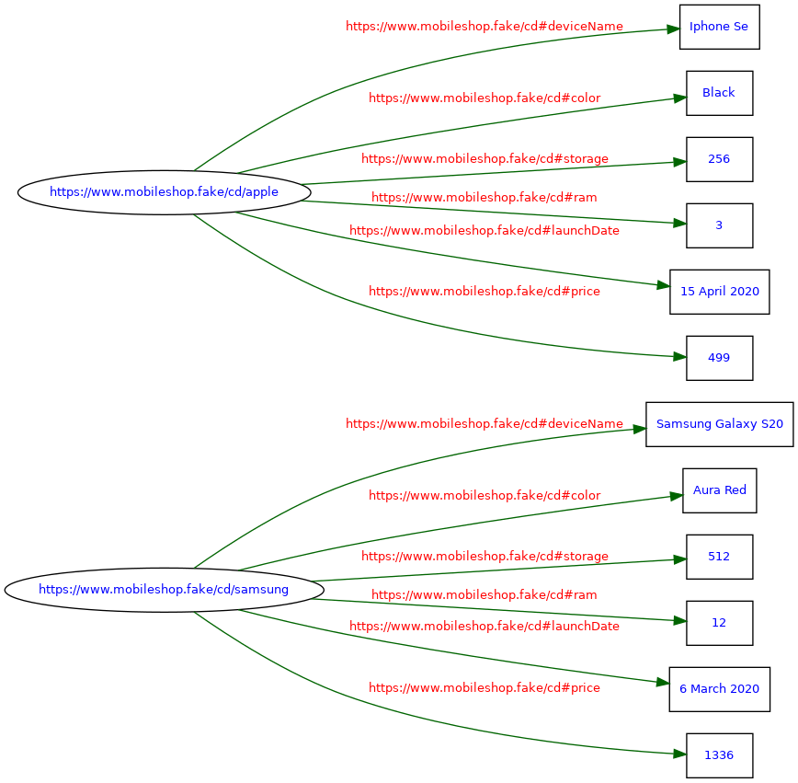
Graph of the data model

Exercise 3: Make RDF file of the given graph.

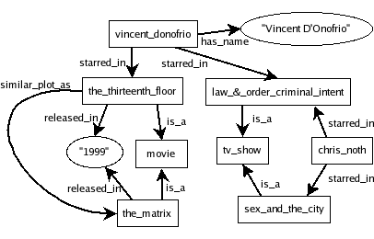

Solution:

@prefix rdf: <http://www.w3.org/1999/02/22-rdf-syntax-ns#> .

@prefix ex: <http://www.example.org/> .

ex:vincent_donofrio ex:starred_in ex:law_and_order_ci .

ex:law_and_order_ci rdf:type ex:tv_show .

ex:the_thirteenth_floor ex:similar_plot_as ex:the_matrix .

<rdf:RDF xmlns:rdf="http://www.w3.org/1999/02/22-rdf-syntax-ns#"

xmlns:ex="http://www.example.org/">

<rdf:Description rdf:about="http://www.example.org/vincent_donofrio">

<ex:starred_in>

<ex:tv_show rdf:about="http://www.example.org/law_and_order_ci" />

</ex:starred_in>

</rdf:Description>

<rdf:Description rdf:about="http://www.example.org/the_thirteenth_floor">

<ex:similar_plot_as rdf:resource="http://www.example.org/the_matrix" />

</rdf:Description>

</rdf:RDF>

Exercise 4: Make RDF file of the given details of subject, predicate and object.

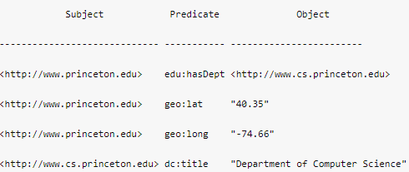

Solution:

<rdf:RDF xmlns:rdf="http://www.w3.org/1999/02/22-rdf-syntax-ns#"

xmlns:dc="http://purl.org/dc/elements/1.1/"

xmlns:geo="http://www. w3.org/2003/01/geo/wgs84_pos#"

xmlns:edu="http://www.example.org/">

<rdf:Description rdf:about="http://www.princeton.edu">

<geo:lat>40.35</geo:lat>

<geo:long>-74.66</geo:long>

<edu:hasDept rdf:resource="http://www.cs.princeton.edu"

dc:title="Department of Computer Science"/>

</rdf:Description>

</rdf:RDF>

Exercise 5: Make RDFa file with given HTML format.

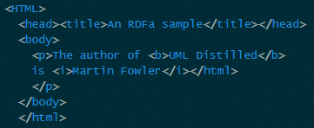

Solution:

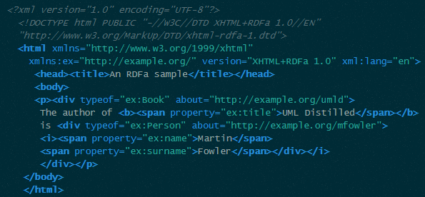

Exercise 6: Make RDFa file for the given HTML page.

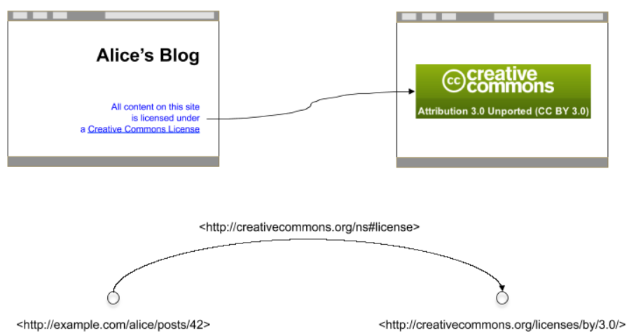

Solution:

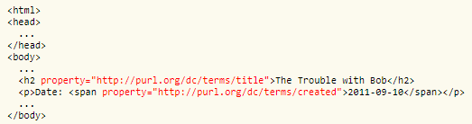

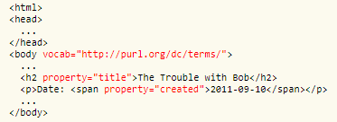

Exercise 7: Make RDFa file for the given RDF graph.

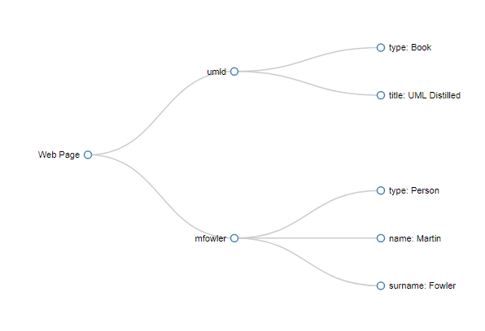
Solution:

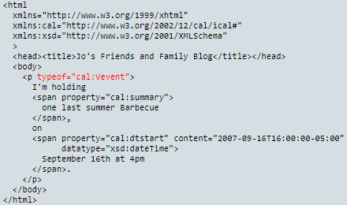

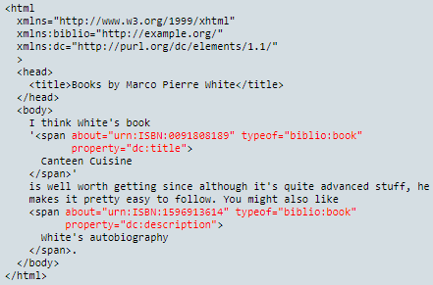

Exercise 8: Make RDFa file for the given RDF graph.

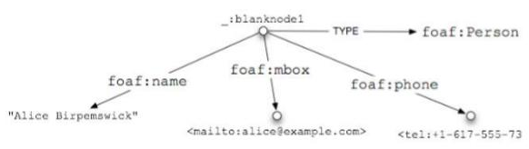

Solution:
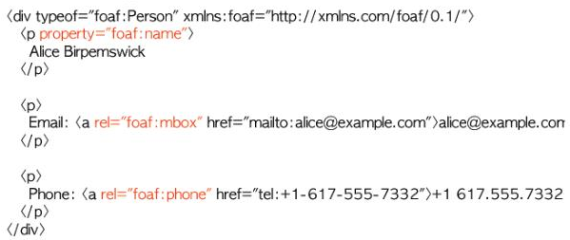

CSE 344 – Semantic Web Lab
Week 9: RDF Schema (RDFS)

Learning Objectives: The objectives of this experiment are:
- What RDF is and how it fundamentally differs from XML and relational databases
- What is meant by a “graph data model”
- How RDF is typically represented visually
- The importance of the URI, and the significance (or lack thereof) of identity “universality”
- Describe in basic terms what the semantic web is.
- Experience the paradigm-shift of storing information as a graph database, rather than a hierarchical or relational database.
- Understand that the semantic web of data is defined using Resource Description Framework (RDF).
- Understand the basic principles of RDF statements and how they can define data graphs.
Your lab report is expected to contain the following for each exercise:
- RDF Source Code
- https://www.w3.org/2015/03/ShExValidata/
- https://www.w3.org/RDF/Validator/
- GraphDB
- Altova
- http://rdfa.info/play/
- https://www.w3.org/2012/pyRdfa/Validator.html#distill_by_uri

Exercise 1: Write an RDF/XML encoding for the story below:

Olivier is a 20 year old Swiss student at EPFL. He speaks fluently English and French. He decides to learn Spanish. Together with his friends, Mark and Claudia, he subscribes for the Spanish course taught by Prof. Garcia every Tuesday at the EPFL Language Center . Olivier is quite talented and makes quick progress. Prof. Garcia notices that Olivier needs to practice speaking in Spanish, so he tells him about another student at EPFL, named Maria.
Maria is a Spanish girl who speaks very good English and is eager to learn French. Olivier meets Maria and they become tandem partners. Having somebody to practice with proves to be very useful and soon Olivier speaks fluently Spanish.

RDF Instances:
<?xml version="1.0"?>

<rdf:RDF xmlns:rdf="http://www.w3.org/1999/02/22-rdf-syntax-ns#"

xmlns:rdfs="http://www.w3.org/2000/01/rdf-schema#"

xml:base="http://lsirwww.epfl.ch/courses/dis/2005ws/exercises/rdf/www/schema.txt">

<rdf:Description rdf:ID="Person">

<rdf:type rdf:resource="http://www.w3.org/2000/01/rdf-schema#Class"/>

</rdf:Description>

<rdf:Description rdf:ID="Student">

<rdf:type rdf:resource="http://www.w3.org/2000/01/rdf-schema#Class"/>

<rdfs:subClassOf rdf:resource="#Person"/>

</rdf:Description>

<rdf:Description rdf:ID="Professor">

<rdf:type rdf:resource="http://www.w3.org/2000/01/rdf-schema#Class"/>

<rdfs:subClassOf rdf:resource="#Person"/>

</rdf:Description>

<rdf:Description rdf:ID="Course">

<rdf:type rdf:resource="http://www.w3.org/2000/01/rdf-schema#Class"/>

</rdf:Description>

<rdf:Property rdf:ID="name">

<rdfs:domain rdf:resource="#Person"/>

<rdfs:range rdf:resource="http://www.w3.org/2001/XMLSchema#string"/>

</rdf:Property>

<rdf:Property rdf:ID="nationality">

<rdfs:domain rdf:resource="#Person"/>

</rdf:Property>

<rdf:Property rdf:ID="age">

<rdfs:domain rdf:resource="#Person"/>

<rdfs:range rdf:resource="http://www.w3.org/2001/XMLSchema#integer"/>

</rdf:Property>

<rdf:Property rdf:ID="foreignLanguage">

<rdfs:domain rdf:resource="#Person"/>

</rdf:Property>

<rdf:Property rdf:ID="tandemPartner">

<rdfs:domain rdf:resource="#Student"/>

<rdfs:range rdf:resource="#Student"/>

</rdf:Property>

<rdf:Property rdf:ID="teacher">

<rdfs:domain rdf:resource="#Course"/>

<rdfs:range rdf:resource="#Professor"/>

</rdf:Property>

<rdf:Property rdf:ID="title">

<rdfs:domain rdf:resource="#Course"/>

<rdfs:range rdf:resource="http://www.w3.org/2001/XMLSchema#string"/>

</rdf:Property>

<rdf:Property rdf:ID="students">

<rdfs:domain rdf:resource="#Course"/>

<rdfs:range rdf:resource="#Student"/>

</rdf:Property>

<rdf:Property rdf:ID="location">

<rdfs:domain rdf:resource="#Course"/>

</rdf:Property>

<rdf:Property rdf:ID="isScheduled">

<rdfs:domain rdf:resource="#Course"/>

</rdf:Property>

<rdfs:Datatype rdf:about="http://www.w3.org/2001/XMLSchema#integer"/>

<rdfs:Datatype rdf:about="http://www.w3.org/2001/XMLSchema#string"/>

</rdf:RDF>

Solution:

<?xml version="1.0" ?>

- <rdf:RDF xmlns:rdf="http://www.w3.org/1999/02/22-rdf-syntax-ns#" xmlns:dc="http://purl.org/dc/elements/1.1/" xmlns:ex="http://lsirwww.epfl.ch/courses/dis/2006ws/exercises/rdf/schema.txt#" xml:base="http://lsirwww.epfl.ch/courses/dis/2006ws/exercises/rdf/your_name">
- <ex:Student rdf:ID="Olivier">
<ex:name>Olivier</ex:name>
<ex:age>20</ex:age>
<ex:nationality>Swiss</ex:nationality>
- <ex:foreignLanguage>
- <rdf:Bag>
<rdf:li>French</rdf:li>
<rdf:li>English</rdf:li>
</rdf:Bag>
</ex:foreignLanguage>
<ex:tandemPartner rdf:resource="#Maria" />
</ex:Student>
- <ex:Student rdf:ID="Maria">
<ex:name>Maria</ex:name>
<ex:nationality>Spanish</ex:nationality>
<ex:foreignLanguage>English</ex:foreignLanguage>
<ex:tandemPartner rdf:resource="#Olivier" />
</ex:Student>
- <ex:Student rdf:ID="Mark">
<ex:name>Mark</ex:name>
</ex:Student>
- <ex:Student rdf:ID="Claudia">
<ex:name>Claudia</ex:name>
</ex:Student>
- <ex:Course rdf:ID="SpanishCourse">
<ex:title>Spanish Course</ex:title>
<ex:teacher rdf:resource="#Garcia" />
<ex:isScheduled>Tuesday</ex:isScheduled>
- <ex:students>
- <rdf:Bag>
<rdf:li rdf:resource="#Olivier" />
<rdf:li rdf:resource="#Mark" />
<rdf:li rdf:resource="#Claudia" />
</rdf:Bag>
</ex:students>
<ex:location>EPFL Language Center</ex:location>
</ex:Course>
- <ex:Professor rdf:ID="Garcia">
<ex:name>Garcia</ex:name>
</ex:Professor>
- <rdf:Statement rdf:about="#Maria_name">
<rdf:subject rdf:resource="#Maria" />
<rdf:predicate rdf:resource="http://lsirwww.epfl.ch/courses/dis/2005ws/exercises/rdf/schema.txt#name" />
<rdf:object>Maria</rdf:object>
<dc:Creator rdf:resource="#Garcia" />
</rdf:Statement>
</rdf:RDF>

Exercise 2: Write an RDF Schema using classes about animals, horse is included in animals class:
Resource "horse" is a subclass of the class "animal".

Solution:

<?xml version="1.0"?>

<rdf:RDF
xmlns:rdf="http://www.w3.org/1999/02/22-rdf-syntax-ns#"
xmlns:rdfs="http://www.w3.org/2000/01/rdf-schema#"
xml:base="http://www.animals.fake/animals#">

<rdf:Description rdf:ID="animal">
<rdf:type rdf:resource="http://www.w3.org/2000/01/rdf-schema#Class"/>
</rdf:Description>

<rdf:Description rdf:ID="horse">
<rdf:type rdf:resource="http://www.w3.org/2000/01/rdf-schema#Class"/>
<rdfs:subClassOf rdf:resource="#animal"/>
</rdf:Description>

</rdf:RDF>

Or

<?xml version="1.0"?>

<rdf:RDF
xmlns:rdf="http://www.w3.org/1999/02/22-rdf-syntax-ns#"
xmlns:rdfs="http://www.w3.org/2000/01/rdf-schema#"
xml:base="http://www.animals.fake/animals#">

<rdfs:Class rdf:ID="animal" />

<rdfs:Class rdf:ID="horse">
<rdfs:subClassOf rdf:resource="#animal"/>
</rdfs:Class>

</rdf:RDF>

Exercise 3: Write an RDF Schema using classes about the given RDF graph.

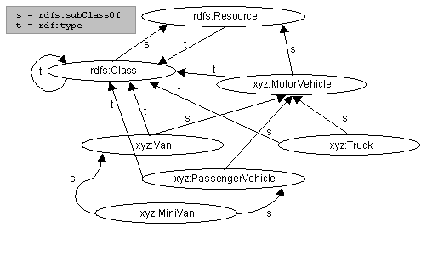
Solution:

<rdf:RDF xml:lang="en"
xmlns:rdf="http://www.w3.org/1999/02/22-rdf-syntax-ns#"
xmlns:rdfs="http://www.w3.org/TR/1999/PR-rdf-schema-19990303#">

<!-- Note: this RDF schema would typically be used in RDF instance data
by referencing it with an XML namespace declaration, for example
xmlns:xyz="http://w3.org/examples/vehicles#". This allows us to use
abbreviations such as xyz:MotorVehicle to refer unambiguously to the
RDF class 'MotorVehicle'. -->

<rdf:Description ID="MotorVehicle">
<rdf:type resource="http://www.w3.org/TR/1999/PR-rdf-schema-19990303#Class"/>
<rdfs:subClassOf
rdf:resource="http://www.w3.org/TR/1999/PR-rdf-schema-19990303#Resource"/>
</rdf:Description>

<rdf:Description ID="PassengerVehicle">
<rdf:type resource="http://www.w3.org/TR/1999/PR-rdf-schema-19990303#Class"/>
<rdfs:subClassOf rdf:resource="#MotorVehicle"/>
</rdf:Description>

<rdf:Description ID="Truck">
<rdf:type resource="http://www.w3.org/TR/1999/PR-rdf-schema-19990303#Class"/>
<rdfs:subClassOf rdf:resource="#MotorVehicle"/>
</rdf:Description>

<rdf:Description ID="Van">
<rdf:type resource="http://www.w3.org/TR/1999/PR-rdf-schema-19990303#Class"/>
<rdfs:subClassOf rdf:resource="#MotorVehicle"/>
</rdf:Description>

<rdf:Description ID="MiniVan">
<rdf:type resource="http://www.w3.org/TR/1999/PR-rdf-schema-19990303#Class"/>
<rdfs:subClassOf rdf:resource="#Van"/>
<rdfs:subClassOf rdf:resource="#PassengerVehicle"/>
</rdf:Description>

</rdf:RDF>

Exercise 4: Write an RDF Schema using classes about the given case study.

A Prototype PICS/RDF Schema
Status: this is work-in-progess illustrating how a PICS schema could be expressed in RDF.

There are three parts:

Part A covers the vocabulary in the PICS-1.1 Label Specification
Part B covers the PICS-1.1 Rating Service Description vocabulary
Part C covers an example PICS rating system from the PICS-1.1 Rating Service Description Specification
A. PICS-1.1 Label Vocabulary
The vocabulary that appears in a PICS-1.1 label is a mixture of descriptions of the service providing the rating, data having to do with the mechanics of transporting the ratings, descriptions of the ratings themselves, and descriptions of the target resource. The vocabulary associated with the transport mechanics (error, for) are not included here. The generic keyword is handled by the RDF aboutURIPrefix mechanism. Two deprecated PICS-1.1 options (signature-RSA-MD5 and MIC-MD5) are omitted from this vocabulary.

The syntax presented in the RDF/XML fragments below assumes that the RDF Model and Syntax namespace is available using the prefix rdf:, and that the RDF Schema namespace is the current default XML namespace.

A.1. Document Properties
The PICS 'at' option is a higher-order relation between the document being rated and the rating statement. As such, it is modelled as a property of the (reified) rating statement.

<rdf:Property ID="at"
comment="The last modification date of the
subject resource at the time the rating was assigned">
<domain rdf:resource="http://www.w3.org/1999/02/22-rdf-syntax-ns#Statement"/>
</rdf:Property>
A.2. Label Options
The rating service URI identifies the source of the labels. In PICS-1.1 the rating system (rating vocabulary) is identified within the service description at the service URI. In PICS/RDF the rating vocabulary should be identified with its own schema (and namespace name). The ratingService property therefore serves only to identify the source of the statements. It is an open question of semantics as to what responsibility the ratingService has for the content of the statements.

<rdf:Property ID="ratingService"
comment="The service from whom this rating was received.">
<domain rdf:resource="http://www.w3.org/1999/02/22-rdf-syntax-ns#Statement"/>
</rdf:Property>
The remainder of the label options identify additional properties of the rating statement itself.

<rdf:Property ID="by"
comment="An identifier for the person or entity within the rating service
who was responsible for creating this particular rating.">
<domain rdf:resource="http://www.w3.org/1999/02/22-rdf-syntax-ns#Statement"/>
</rdf:Property>

<rdf:Property ID="on"
comment="The date on which this rating was issued.">
<domain rdf:resource="http://www.w3.org/1999/02/22-rdf-syntax-ns#Statement"/>
</rdf:Property>
The PICS 'until' label option can also be written as 'exp'. We could use subPropertyOf to represent this synonym; instead, we eliminate it altogether in this respresentation of PICS.

<rdf:Property ID="until"
comment="The date on which this rating expires.">
<domain rdf:resource="http://www.w3.org/1999/02/22-rdf-syntax-ns#Statement"/>
</rdf:Property>
A.3. Other Information
The collection of statements may have the following two properties.

<rdf:Property ID="comment"
comment="Information for humans who may see the label; no associated semantics.">
<domain
rdf:resource="http://www.w3.org/TR/1999/PR-rdf-schema-19990303#Container"/>
</rdf:Property>
The 'completeLabel' property will appear only on a container that has not (yet) been replaced by the contents of the complete label resource. When the complete label is used, the statements in the original collection are withdrawn from the database and the statements in the complete label resource are added.

<rdf:Property ID="completeLabel"
comment="A complete label that can be used in place of the current one.">
<domain
rdf:resource="http://www.w3.org/TR/1999/PR-rdf-schema-19990303#Container"/>
</rdf:Property>
B. PICS-1.1 Rating Service Description Vocabulary
A PICS Rating Service Description is essentially a schema. Some of the vocabulary used in PICS-1.1 translates directly to the RDF Schema vocabulary. In this RDF representation of PICS the rating system is specified separately from the rating service, rather than as a part of the rating service.

<rdf:Property ID="ratingService"
comment="A document describing the rating service in human-readable terms."/>

<rdf:Property ID="icon"
comment="A graphic associated with the rating service or with a
specific rating property."/>

The following properties are used within the rating system schema to describe the schema and the properties within the schema.

<rdf:Property ID="name"
comment="The name of the rating system."/>

<rdf:Property ID="description"
comment="A human-readable description of the rating system."/>

<rdf:Property ID="minimum"
comment="The minimum numeric value permitted."/>

<rdf:Property ID="maximum"
comment="The maximum numeric value permitted."/>

<Class rdf:ID="Integer"
comment="Integer numbers."/>

<Class rdf:ID="Encoding"
comment="A value with a label"/>

<Class rdf:ID="Multivalue">
<subClassOf resource="http://www.w3.org/1999/02/22-rdf-syntax-ns#Bag"/>
<!-- used as the range of properties that can take either a singleton or a Bag as their value -->
</Class>

<Class rdf:ID="Multiordered">
<subClassOf resource="http://www.w3.org/1999/02/22-rdf-syntax-ns#Seq"/>
<!-- used as the range of properties that can take either a singleton or a Seq as their value -->
</Class>
'Categories' and the transmit-as property are simply the property name. The category name is the RDF label property.

Solution:

<Description
xmlns="http://www.w3.org/1999/02/22-rdf-syntax-ns#"
xmlns:rdf="http://www.w3.org/1999/02/22-rdf-syntax-ns#"
xmlns:s="http://www.w3.org/TR/1999/PR-rdf-schema-19990303#"
xmlns:p="http://www.w3.org/TR/WD-pics2.0#"
about="">

<p:icon rdf:resource="icons/gcf.gif"/>
<p:name>The Good Clean Fun Rating System</p:name>
<p:description>Everything you ever wanted to know about soap, cleaners, and
related products. For demonstration purposes only.</p:description>
</Description>

<Property ID="suds"
s:label="Soapsuds Index"
p:minimum="0.0"
p:maximum="1.0"/>

<Property ID="density"
s:label="suds density">
<s:range rdf:resource="#DensityValue"/>
</Property>

<Bag ID="DensityValue">
<li>
<p:Encoding
rdf:value="0"
s:label="none">
<p:icon rdf:resource="icons/none.gif"/>
</p:Encoding>
</li>
<li>
<p:Encoding
rdf:value="1"
s:label="lots">
<p:icon rdf:resource="icons/lots.gif"/>
</p:Encoding>
</li>
</Bag>

<Property ID="subject"
s:label="document subject">
<s:range rdf:resource="#SubjectValue">
</Property>

<p:Multivalue rdf:ID="SubjectValue">
<li>
<p:Encoding
rdf:value="0"
s:label="soap"/>
</li>
<li>
<p:Encoding
rdf:value="1"
s:label="water"/>
</li>
<li>
<p:Encoding
rdf:value="2"
s:label="soapdish"/>
</li>
</p:Multivalue>

<Property ID="color"
s:label="picture color">
<s:range resource="#ColorValue">
</Property>

<s:Class rdf:ID="ColorValue"/>

<Property ID="hue"
s:label="hue">
<s:domain rdf:resource="#ColorValue"/>
<s:range rdf:resource="#HueValue"/>
</Property>

<p:Multivalue rdf:ID="HueValue">
<li>
<p:Encoding
rdf:value="0"
s:label="blue"/>
</li>
<li>
<p:Encoding
rdf:value="1"
s:label="red"/>
</li>
<li>
<p:Encoding
rdf:value="2"
s:label="green"/>
</li>
</p:Multivalue>

<Property ID="intensity">
<s:domain rdf:resource="#ColorValue"/>
<s:range rdf:resource="http://www.w3.org/TR/WD-pics2.0#Integer"/>
<p:minimum>0</p:minimum>
<p:maximum>255</p:maximum>
</Property>

CSE 344 – Semantic Web Lab
Week 10 & 11: Ontology building by using protégé, Create classes, sub-classes, object type properties, data type properties, annotation Type properties, Setting of Domain, Range, URI, Prefixes, inverse, transitive and symmetric properties with OWL-RDF Language

Learning Objectives: The objectives of this experiment are:
- What OWL is and how it fundamentally differs from RDF/XML and relational databases
- How to create classes/ sub classes
- How to create individuals, object type properties, data type properties, domain, range, annotations, assertions and forms.
- Define inverse properties, symmetric, inverse symmetric, reflexive, inverse reflexive, transitive and inverse transitive etc
Your lab report is expected to contain the following for each exercise:
- Protégé
- Ontorion Fluent Editor

Exercise 1: Create classes/ sub classes, create individuals, object type properties, data type properties, domain, range, annotations, assertions and forms, using Protégé.

The Star Trek ontology was written as part of Paulo Costa's PhD Dissertation, as a means to have a case study on probabilistic ontologies. We also used this toy ontology to convey most of our explanations in this web site. The option for constructing a case study based on the popular Paramount's television series Star Trek was taken as a means to avoid choosing a particular real-life domain that would pose the risk of getting bogged down into domain-specific details. Nonetheless, the examples presented is this website have been constructed in a way to be accessible to anyone having some familiarity with space-based science fiction. It is a very simple depiction of a (quite interesting) fictional domain that focus on the specific problem of detecting enemy starships. The ontology can be downloaded as an pr-owl/owl file (StarTrek.owl), while Protègè users might want to also donwload its respective project files (StarTrek.pprj and StarTrek.repository).

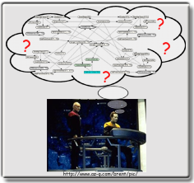

Solution:

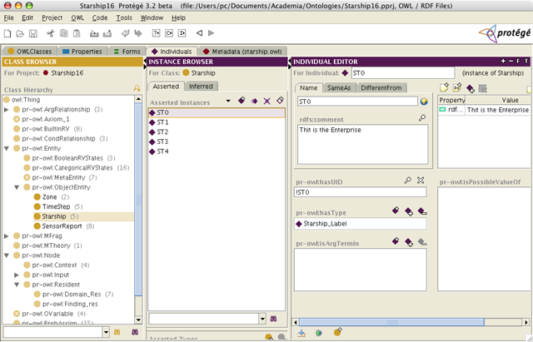

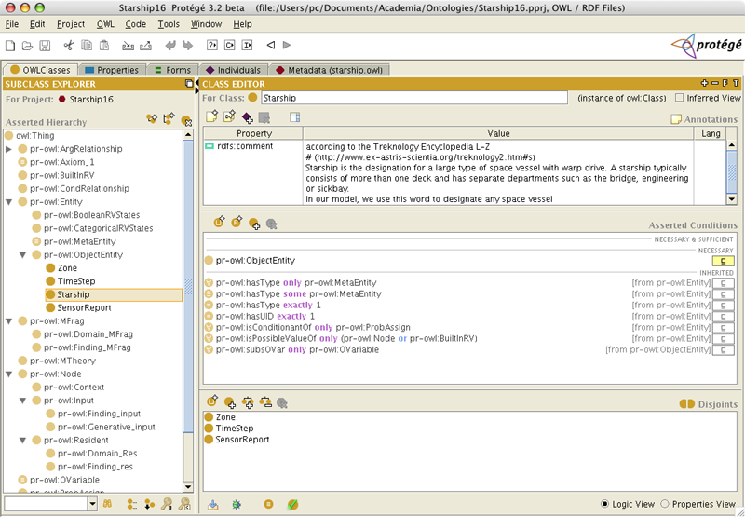

Exercise 1: Create classes/ sub classes, create individuals, object type properties, data type properties, domain, range, annotations, assertions and forms, using Protégé.

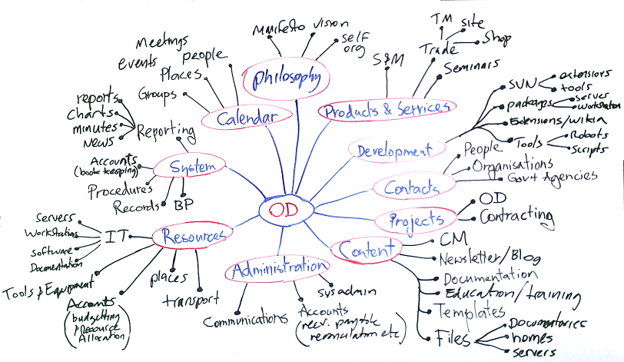

Solution:

Creation of Ontology
The next step is to create your ontology in the Protégé. To do that, click on the “Entities” tab. When clicked, by default you will be put inside the “Classes” sub tab.

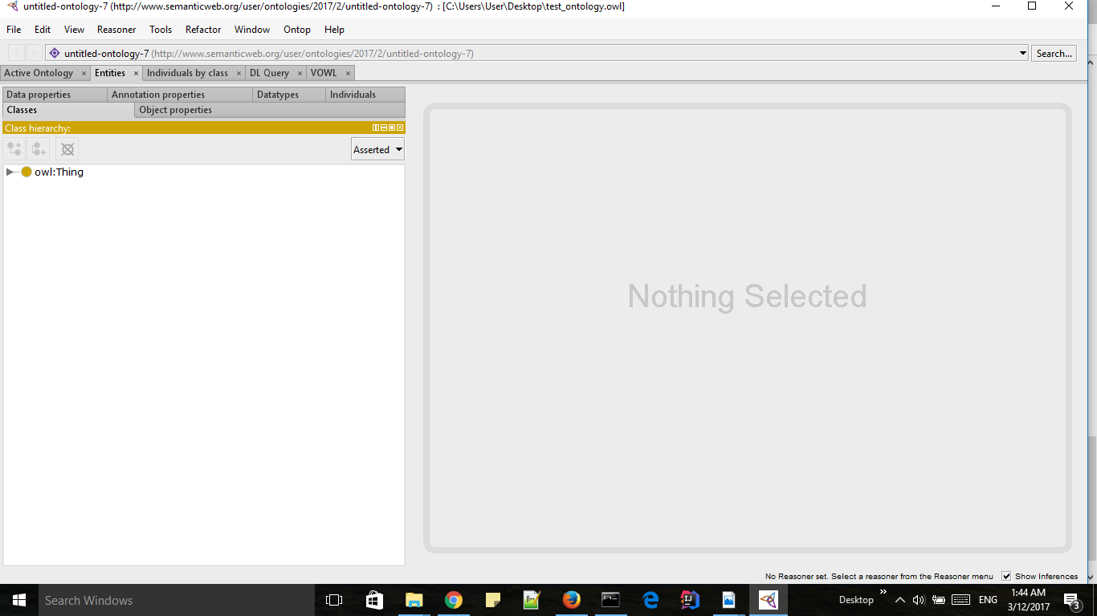
Figure 2: Entities tab view
In this example, we will be looking into creating an ontology based on very basic concepts/scenarios in a university.
1. Teachers teach modules
2. Students study modules.
With those two concepts in hand, following classes, data properties, object properties and individuals could be identified.
Classes
Classes in ontologies are abstract groups, sets or collections of objects.
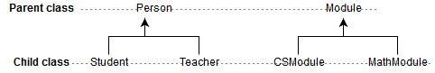
Figure 3 : Classes
Object Properties
In object properties we are concerned with describing how classes can relate to each other based on their instances.
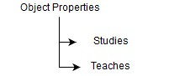
Figures 4 : Object Properties
Data Properties
Data properties are just like object properties except their domains are typed literals.
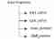
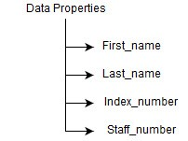
Figure 5 : Data Properties
Individuals
Individuals (instances) are the basic, “ground level” components of an ontology.
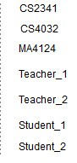
Figure 6: Individuals
For the simplicity purpose, certain data properties are omitted by intention.
Next step involves creating the identified classes, data properties, object properties in the ontology.
Creating Classes
- Click on the classes tab and open the class hierarchy.
- Note that all classes identified above are sub classes of “Thing” class by default.
- Click on “Add subclass” icon and in the pop up menu, give the name of the class.
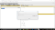
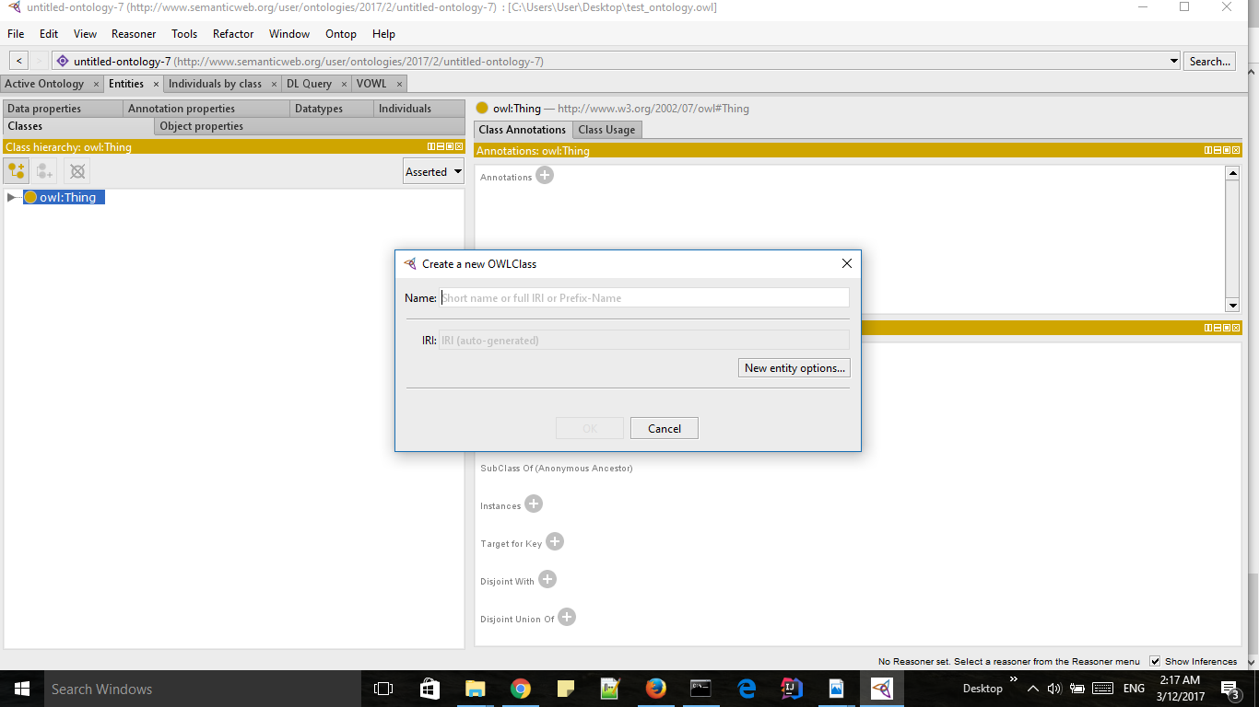
Figure 7 : Create class pop up
Remember to follow the class taxonomy identified in Figure 3 in creating the classes here. For an example, Class “Teacher” should be a sub class of “Person” class where “Person” class is again a subclass of “Thing” class. After creating class taxonomy, you should have the following class hierarchy defined.
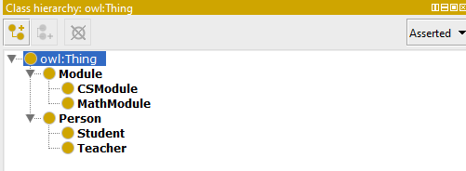
Figure 8 : Class hierarchy
Creating Object Properties
To create the identified object properties in the Figure 4, select the Object Properties tab and click on “Add sub property” icon. Note that all properties will be sub properties of the “topObjectProperty” by default.
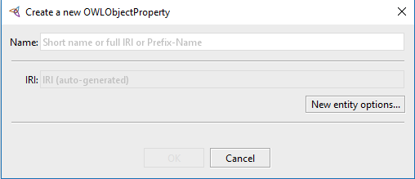
Figure 9 : Add new object property
However it should be noted that we can add domain and range to these object properties.
Syntactically, domain is a built-in property that links a property to a class description. An domain axiom asserts that the subjects of such property statements must belong to the class extension of the indicated class description.
Range is a built-in property that links a property to to either a class description or a data range. An range axiom asserts that the values of this property must belong to the class extension of the class description or to data values in the specified data range.
Hence for the object property “studies” we can add “Student” as the domain and “Module” as the range.
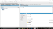
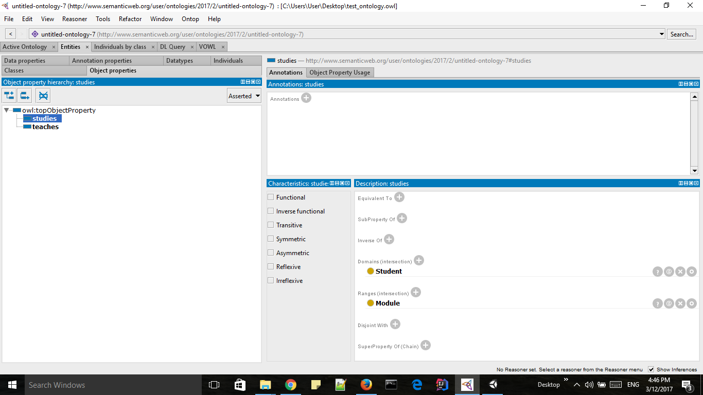
Figure 10 : Add domain and range for object property “studies”
To add domain or range, simply click on the + button near the required item and select the items you want to add.
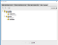
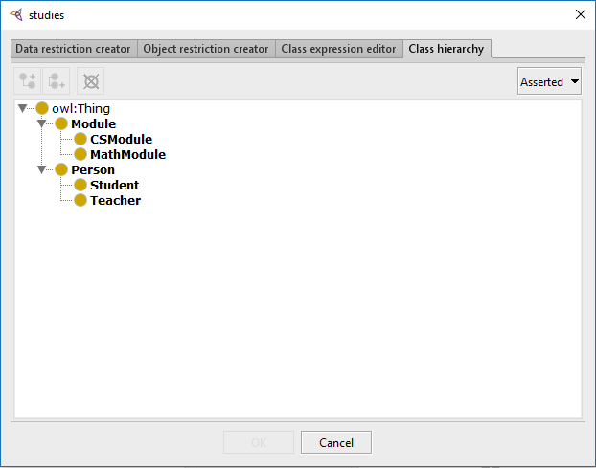
Figure 11 : Select domain or range for “studies” object property
In the same way, for the object property “teaches” we can add “Teacher” as the domain and “Module” as the range.
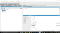
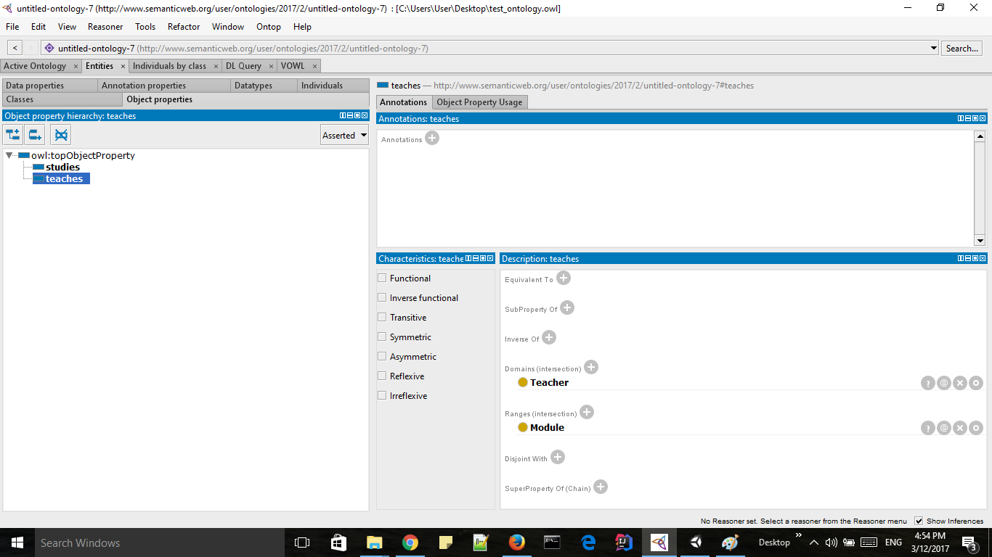
Figure 12 : Add domain and range for object property “teaches”
Creating Data Properties
The next step is to create the identified data properties in Figure 5. To do this, simply click on the “Data Properties” tab and click “Add sub property” icon. Note that all properties will be sub properties of the “topDataProperty” by default.
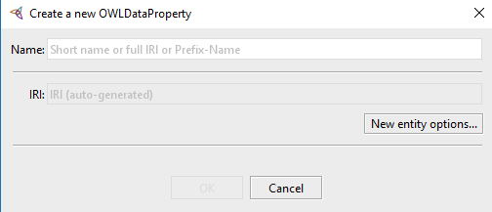
Figure 13 : Add new data property
After adding all the data properties identified, you should get the following overview.
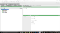
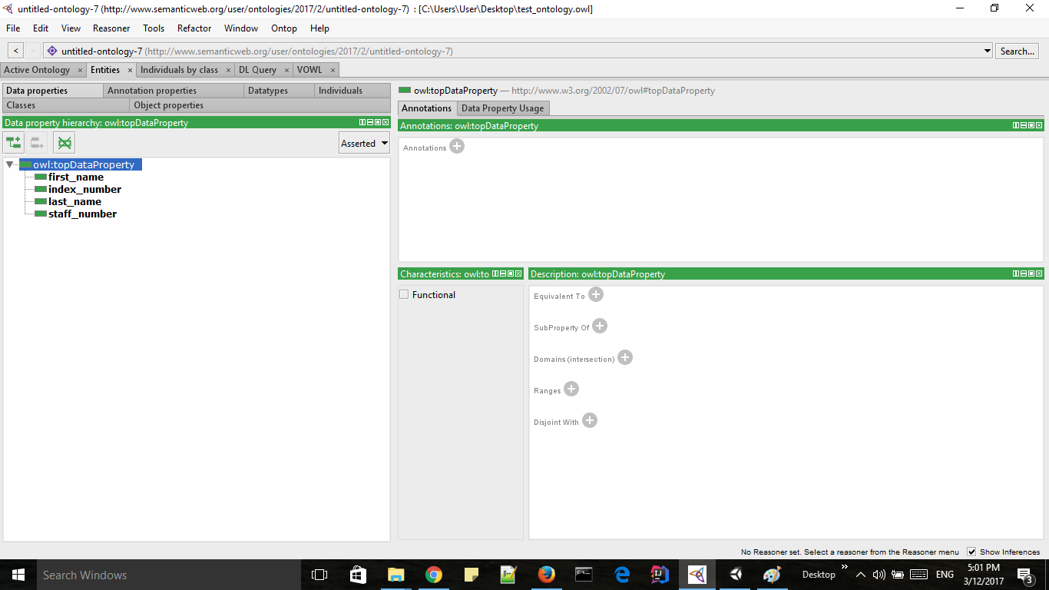
Figure 14 : Data property final overview
In the same way, we did with object properties, we can define domain and range for each data property as well. However, in the range selection, rather having a class description,need to add a data types. For an example,
“first_name” data property has the range of “xsd:string”.
To add this data types click on the + button near “Range”and select “Built in data types” and select the relevant data type from the given list.
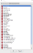
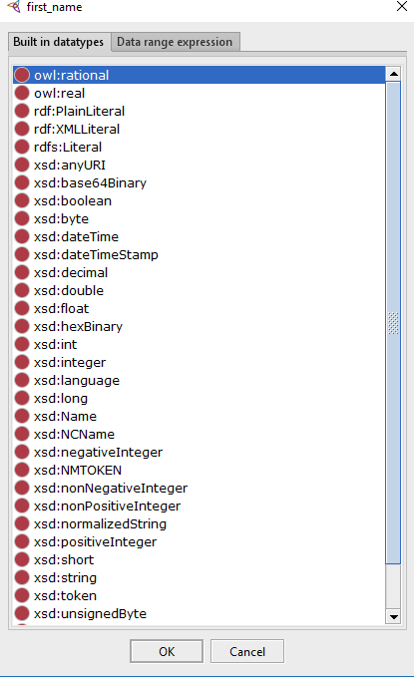
Figure 15 : Select the range for first_name
Add the following ranges to the other identified data properties as well.
first_name → xsd:stringlast_name → xsd:stringindex_no → xsd:intstaff_id → xsd:int
Adding Individuals
The final task in creating the ontology is adding individuals. To do this, click on the “individuals” tab and click on the “Add individual” icon.
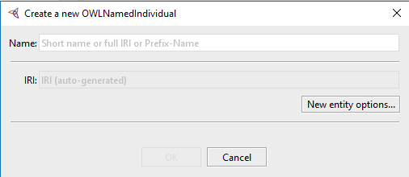
Figure 16 : Add new individual
First, let’s create a “Module” individual. Follow the below steps to set the individual properly.
- Create the “Module” individual “CS2341”.
- Add the Type for the “CS2341” as “Module”.
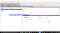
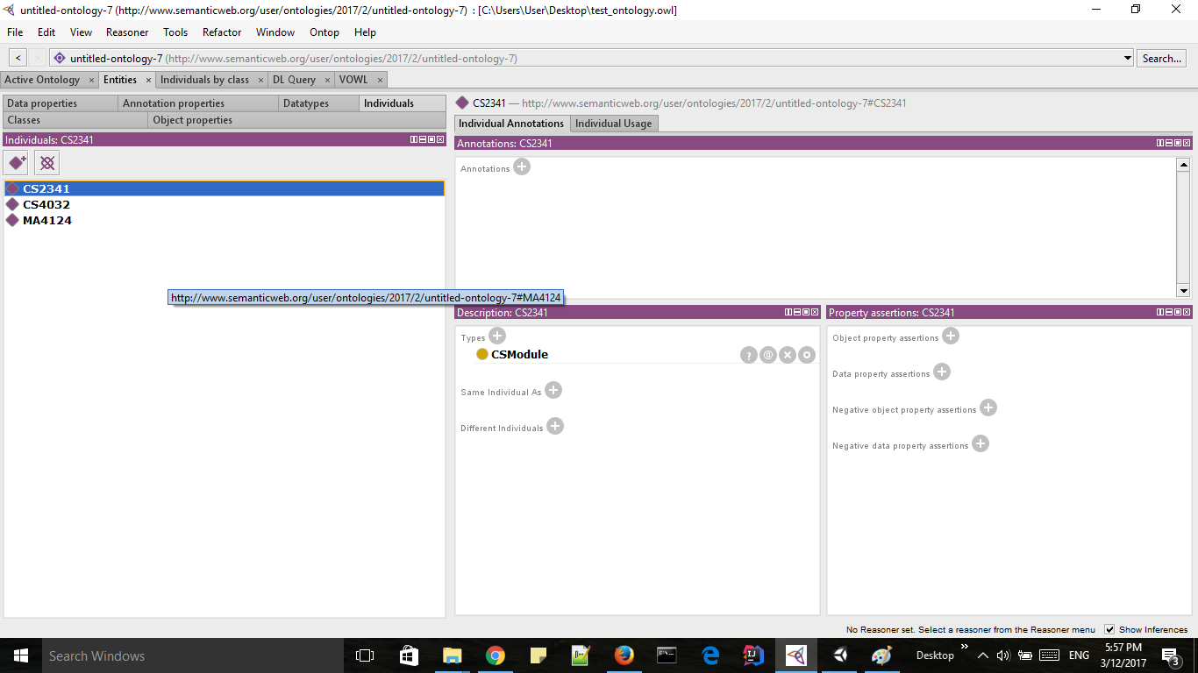
Figure 17 : Define “CS2341” module individual
Do the same for other two modules “CS4032” and “MA4124”.
Secondly, let’s add individual “Student_1”. Follow the below steps to set the individual properly.
- Create the individual “Student_1”.
- Add the Type for the “Student_1” as “Student”.
- Add the object properties for “Student_1”.
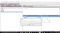
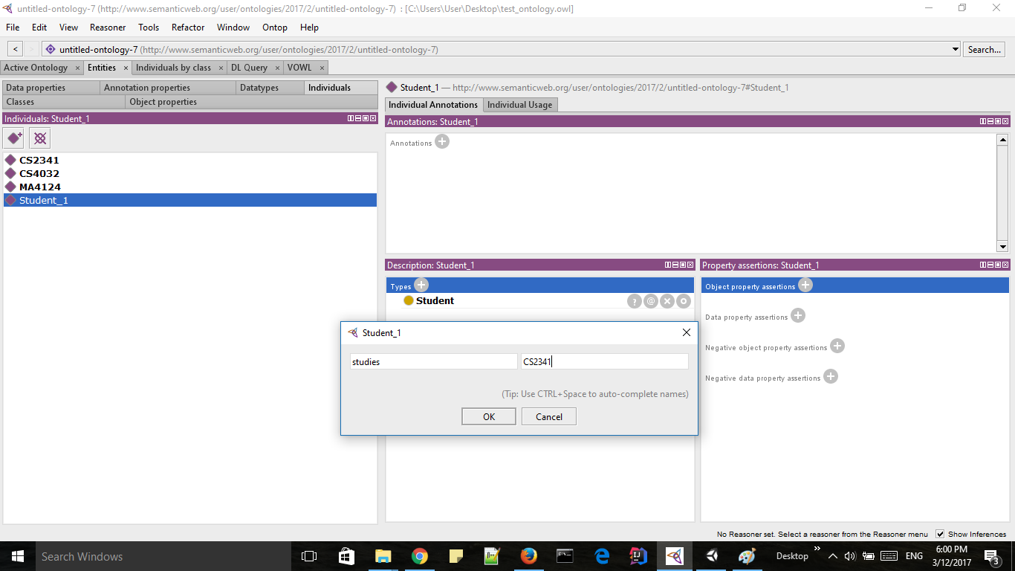
Figure 18 : Adding object properties to “Student_1”
4. Add the data properties to the “Student_1”. Refer below image for more details.
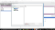
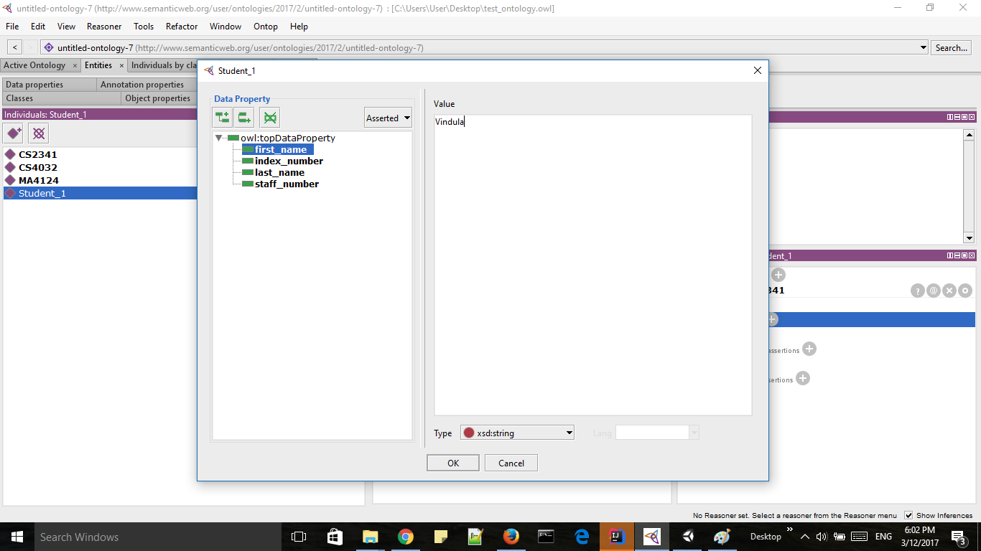
Figure 19 : Add first_name data property to Student_1
First select the “first_name” data property and then select type as “xsd:string”. Finally add the the value in the space provided (in the above example value = Vindula). Do the same for other data properties as well.
After finishing the above iterative process you should get the “Student_1” individual as below.
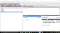
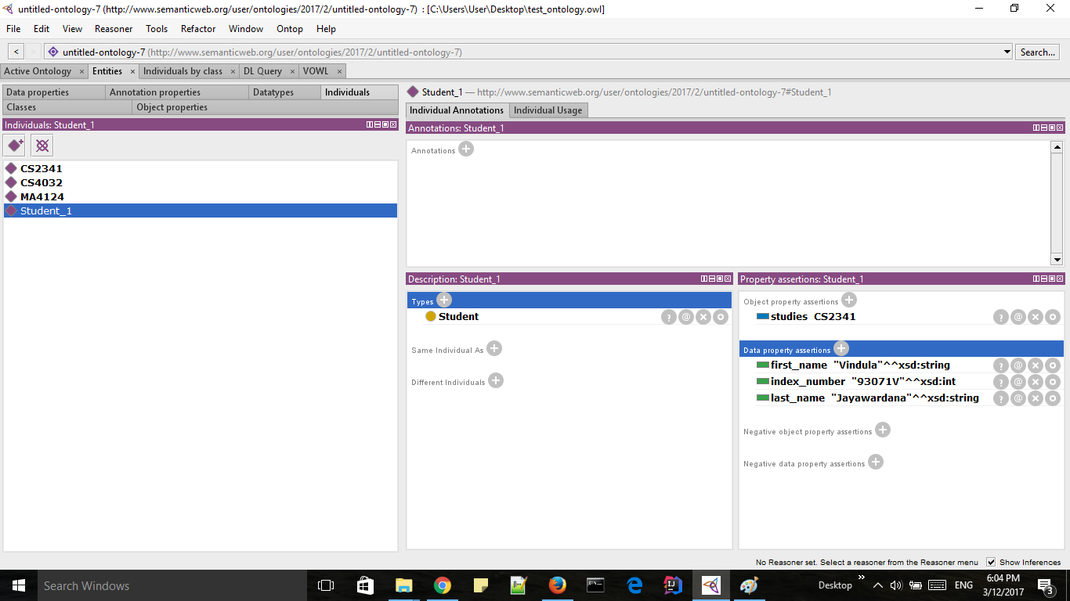
Figure 20 : Final “Student_1” setting
In the same way create the other individuals identified in Figure 6.
If you have completed the above steps correctly, Congratulations!! you just created the university ontology. Now the next step is visualization of the created ontology. Alternatively you could download the created ontology as an OWL file by File → Save As → OWL/XML Syntax.

Visualization of the Ontology
To visualize the ontology in the graphical manner, we need to install the ProtégéVOWL plugin. You can download the jar file from here. After downloading the VOWL jar, copy it to the plugins folder of Protégé, re-start Protégé and activate the plugin via Window → Tabs → VOWL.
That’s it. Simply click the “VOWL” tab in the Protégé and you could see the ontology created in graphical manner as below.
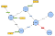
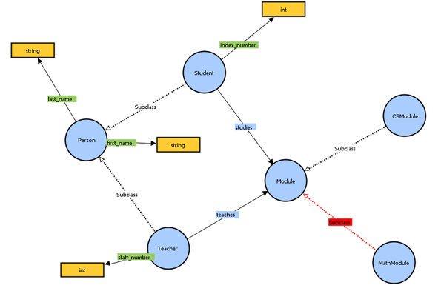
Figure 21 : Final Ontology view

Exercise 3: Create classes/ sub classes, create individuals, object type properties, data type properties, domain, range, annotations, assertions and forms, using Protégé.

Consider a case study and apply all step on it using Protégé.
1. Entity relationship diagram
2. Ontology – classes, subclasses, object-type properties, data-type properties, individuals, assertations
3. Run any 5 queries via SPARQL
4. Start and validate via reasoner run DL query (5 different relational activities) stop reasoner
5. OntoGraf draw your entire structure

Solution:

Question: 1 Entity Relationship Diagram
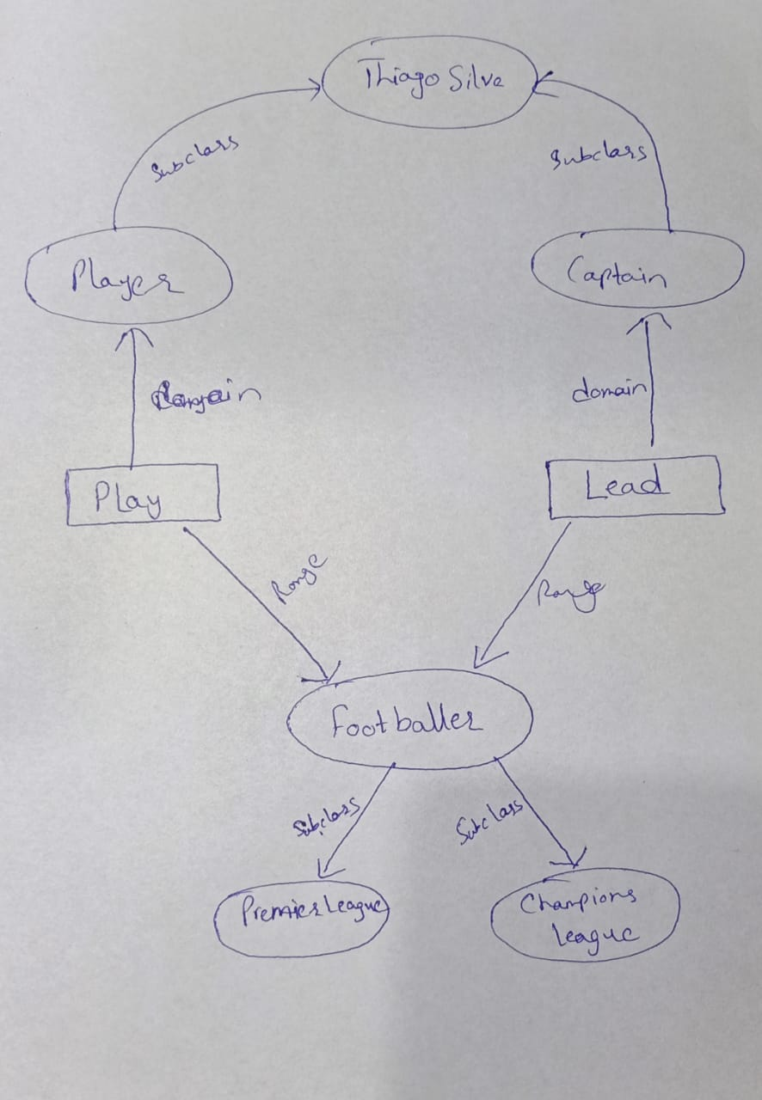

Question: 2

Classes and Subclasses

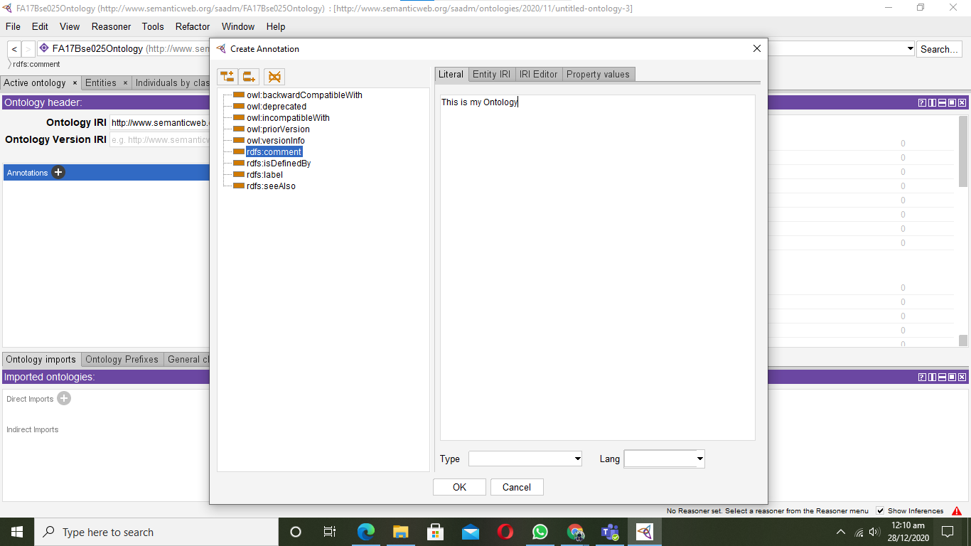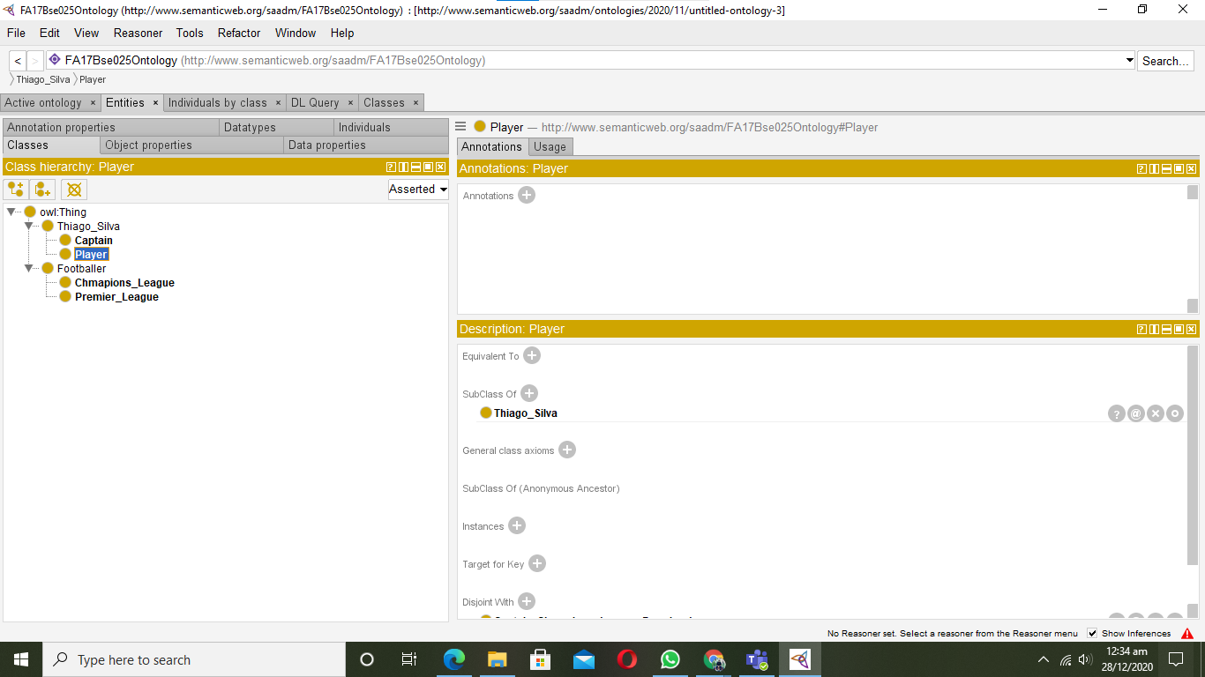

Object Type Properties

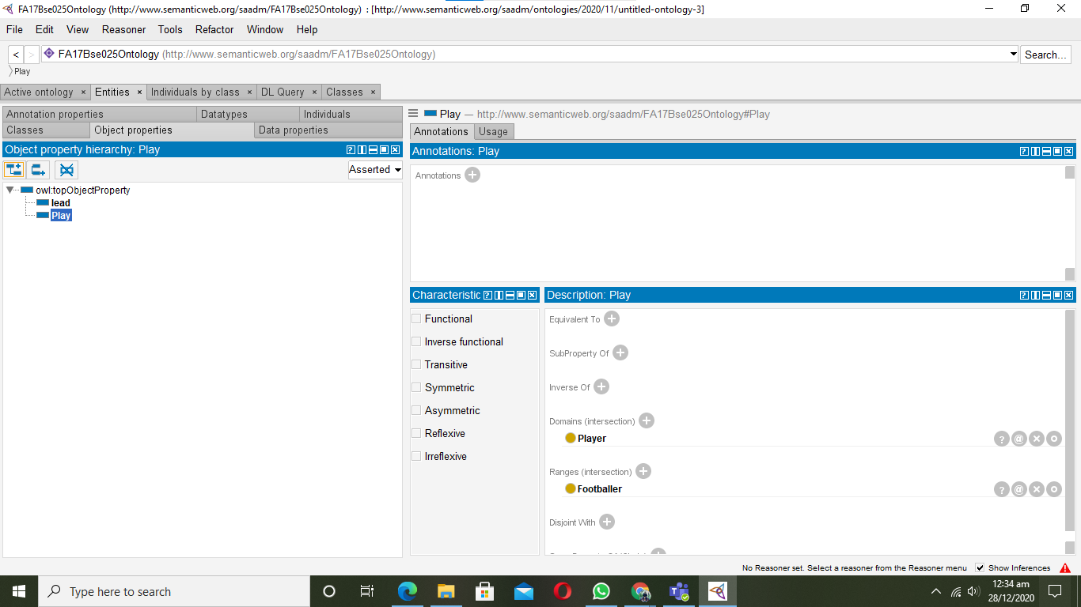

Data Type Properties
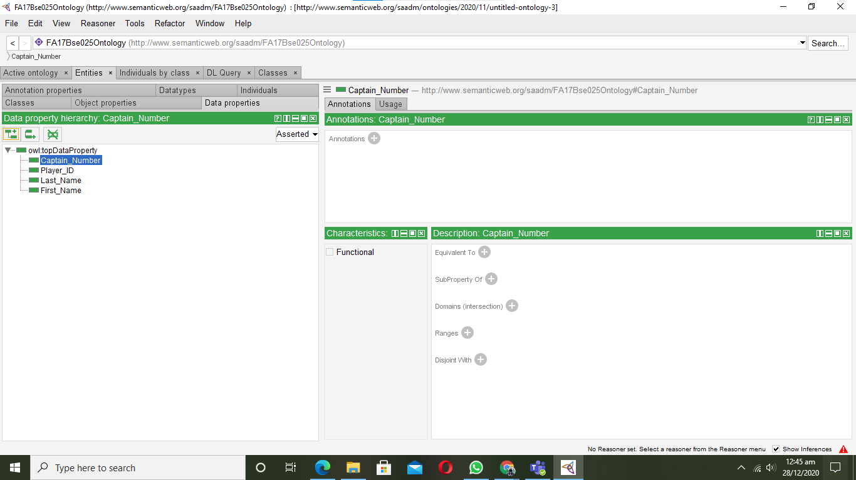

Individuals
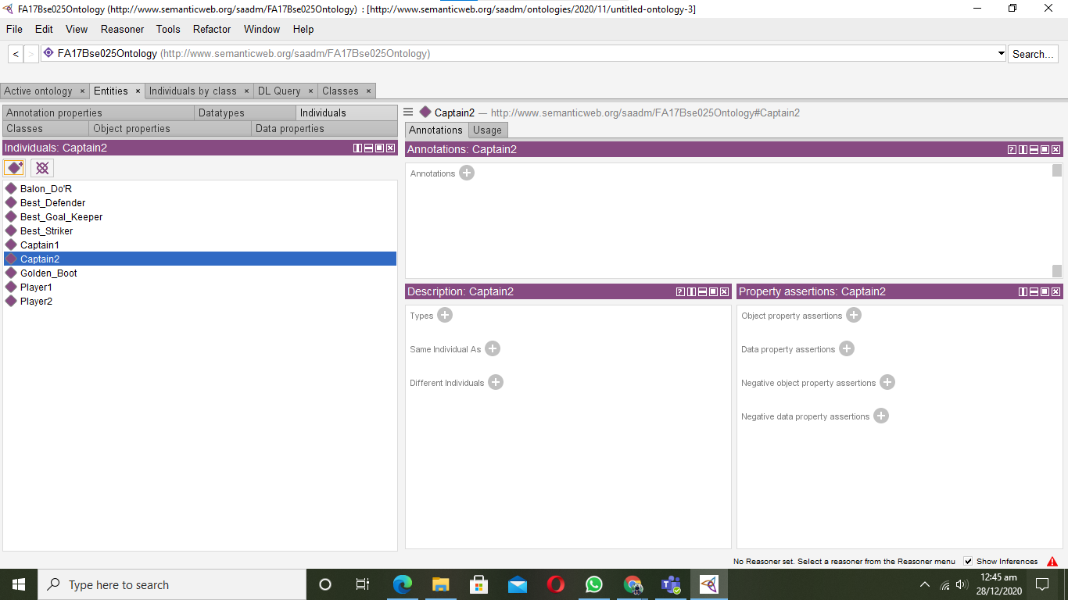

Assertions
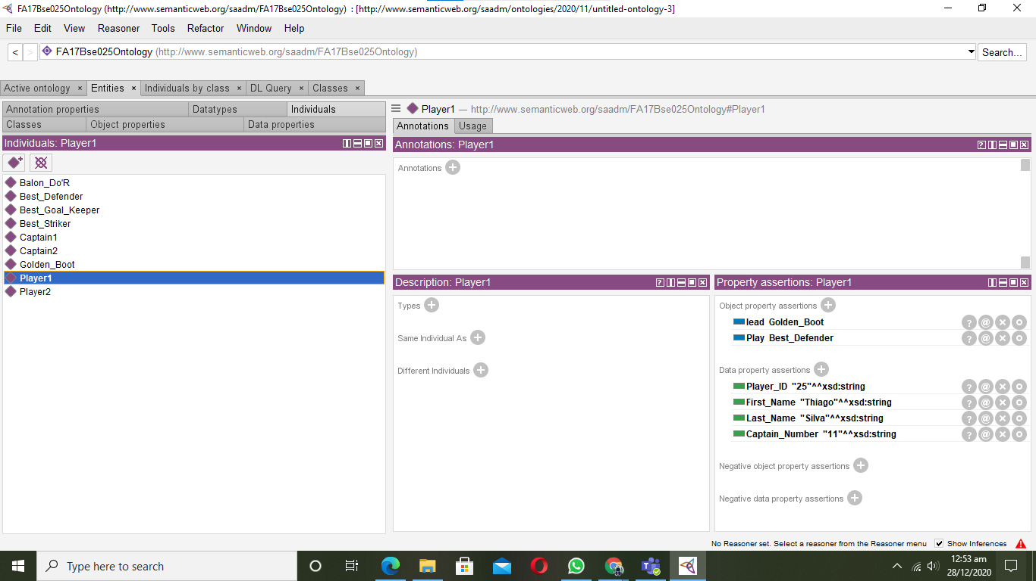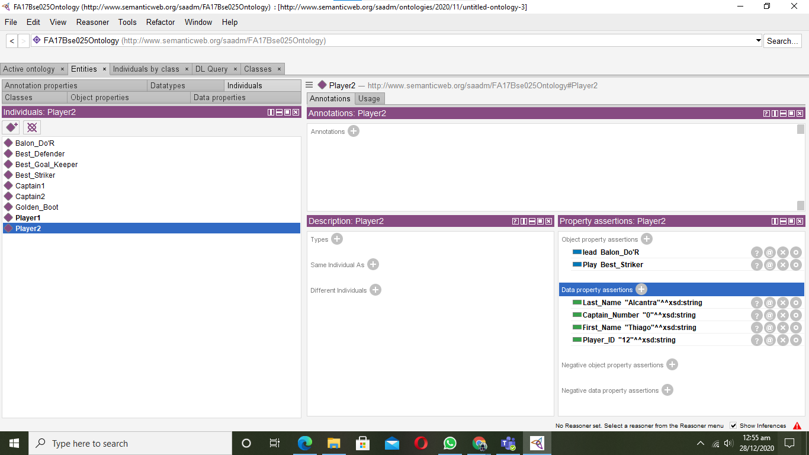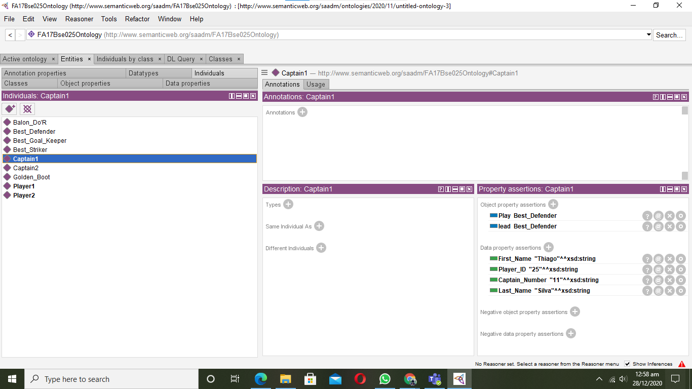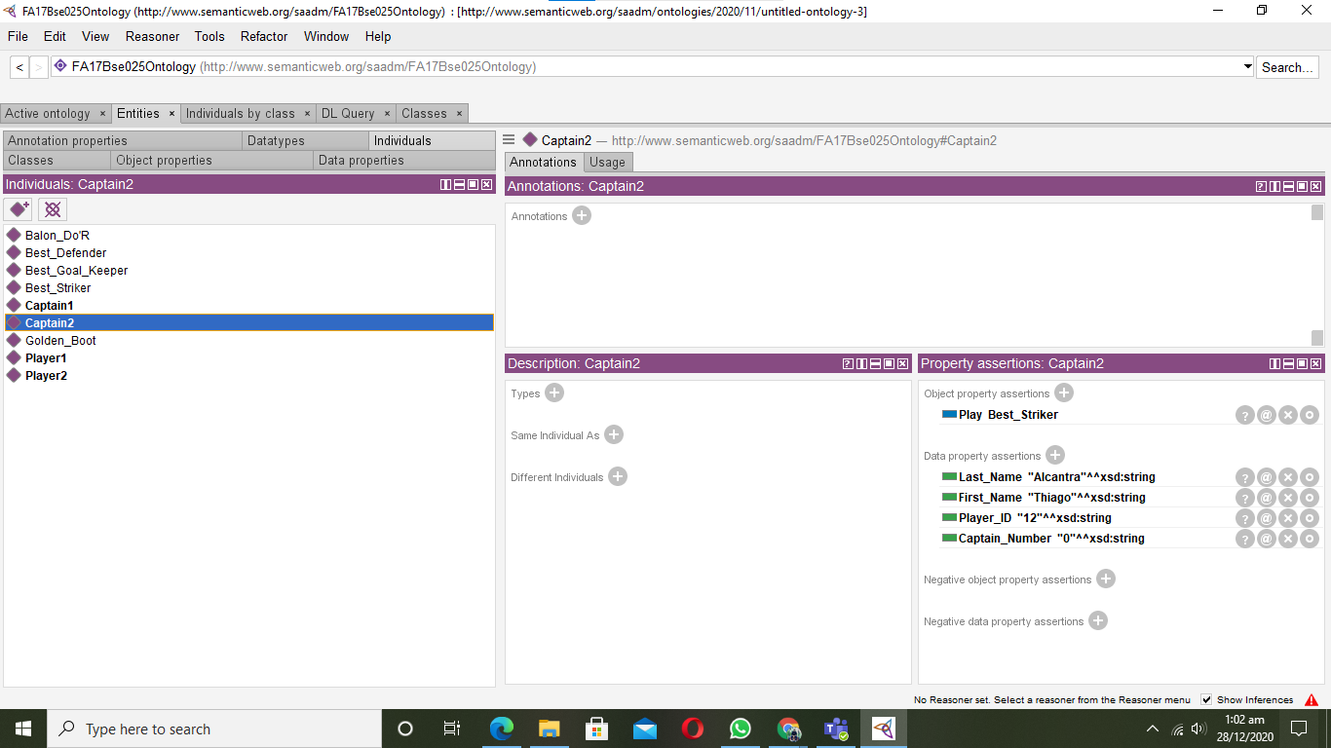

Question: 3 (5 queries via SPARQL)

Queries are Visible in Screenshots

Query-1
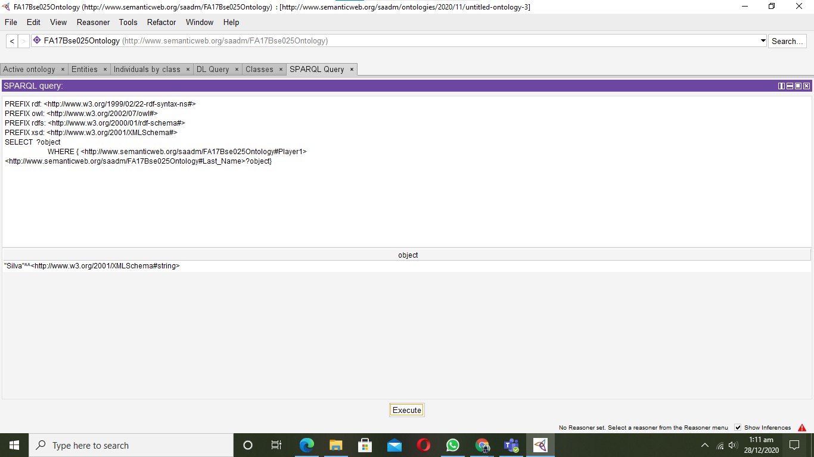

Query-2
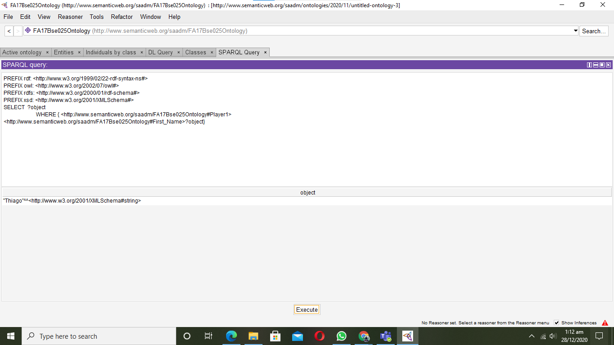

Query-3
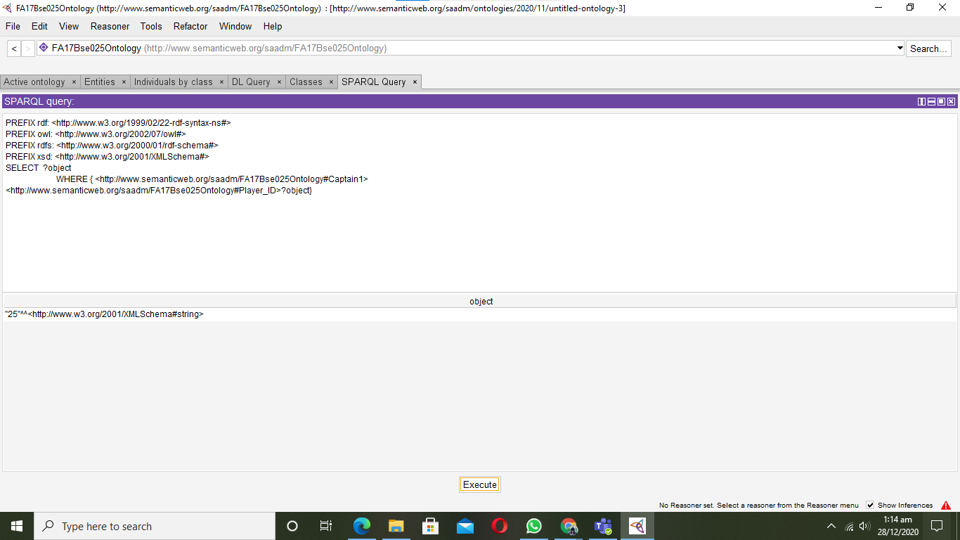

Query-4
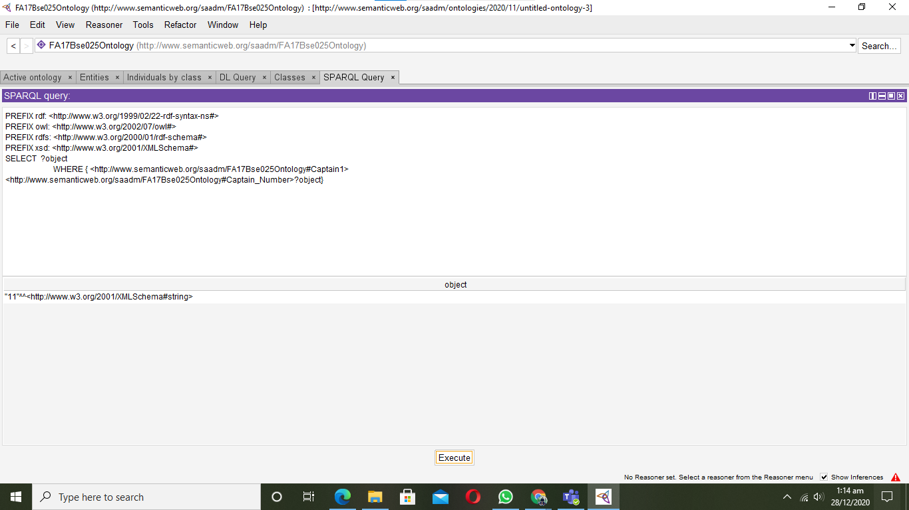

Query-5
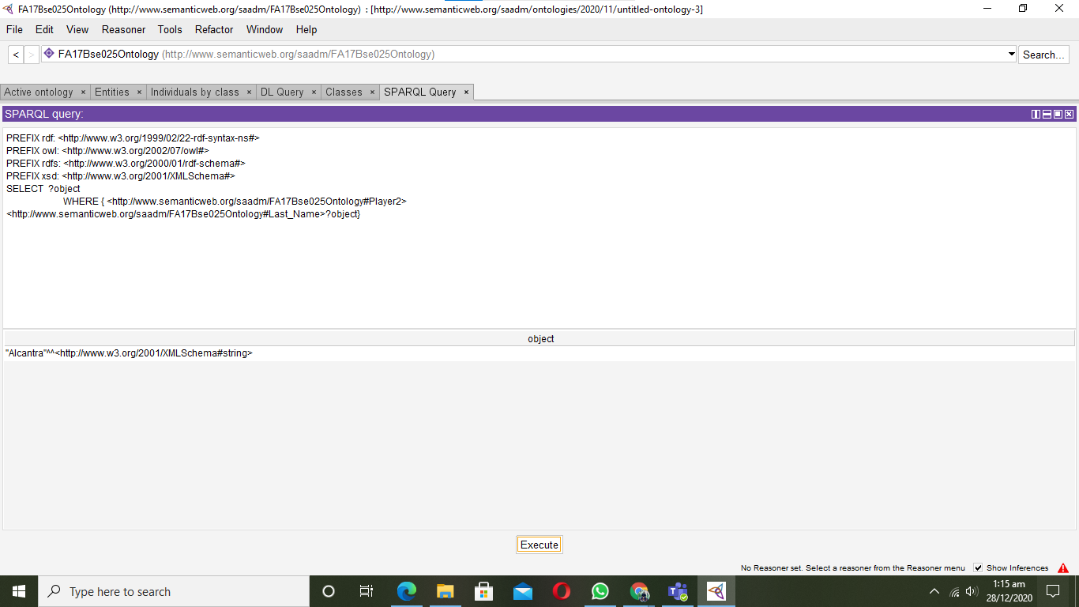

Question: 4
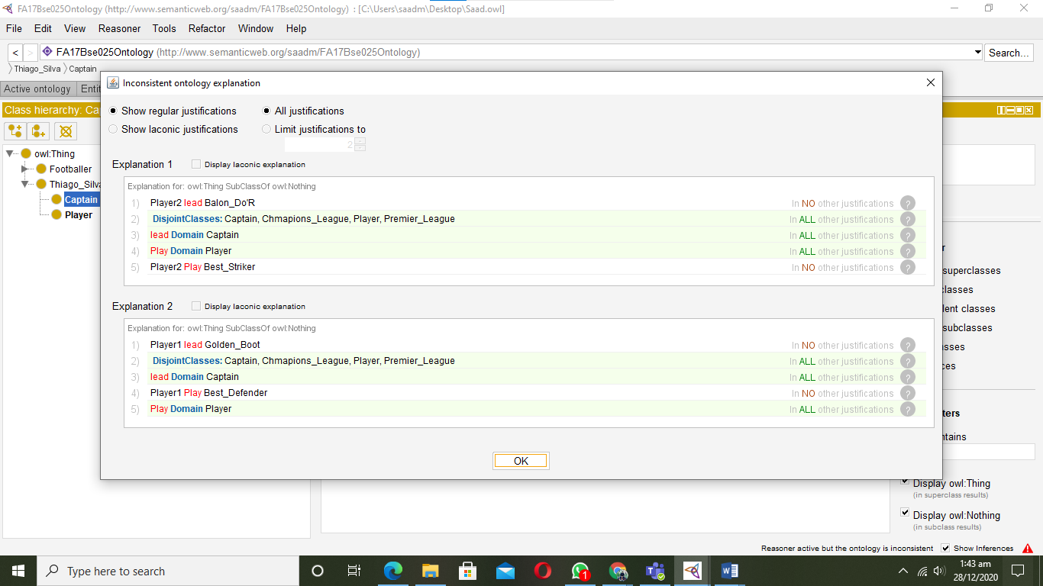

Question: Onto Graf
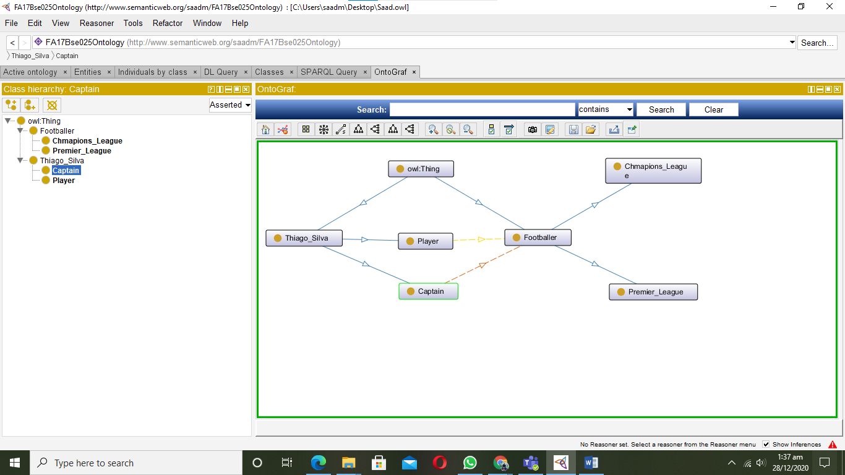

CSE 344 – Semantic Web Lab
Week 12 & 13: DL query using reasoning and Ontograf building using Protege

Learning Objectives: The objectives of this experiment are:
- What OWL is and how it fundamentally differs from RDF/XML and relational databases
- How to create classes/ sub classes
- How to create individuals, object type properties, data type properties, domain, range, annotations, assertions and forms.
- Define inverse properties, symmetric, inverse symmetric, reflexive, inverse reflexive, transitive and inverse transitive etc
Your lab report is expected to contain the following for each exercise:
- Protégé
- Ontorion Fluent Editor

Exercise 1: Create DL query results of cc.owl file using protégé.

Solution:

Go to the ‘basic-dl-query’ folder in the Exercises directory and open the file cc.owl.
This illustrates basic DL (description logic) queries.
A DL query is a class expression that is constructed using constructs such as ‘and’ (corresponding to set intersection) and ‘some’ (see previous example).
Note that the example that follows this one also revisits DL queries.
Constructs used: ‘and’, ‘some’
- open cc.owl
- Turn on the ELK reasoner
- Go to DL query tab
- Find all subtypes of chromosome
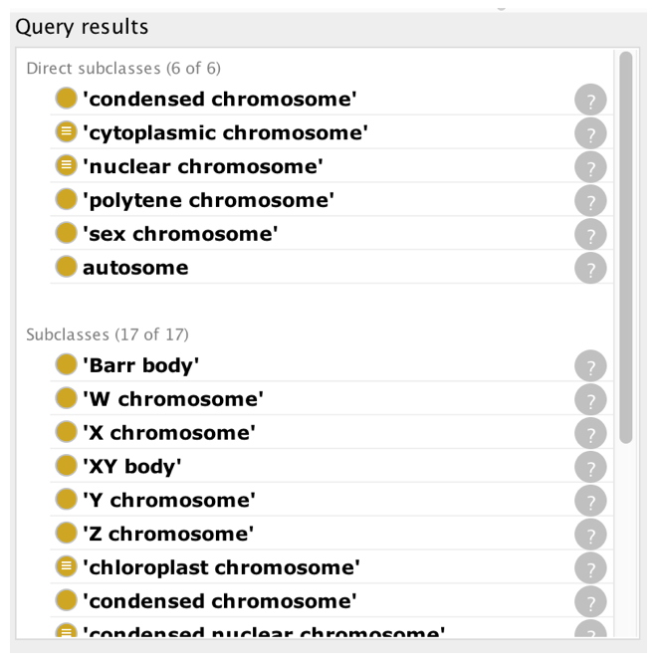
- Experiment with the tab - what do the different checkboxes give you?
- Find all parts of a cytoplasm
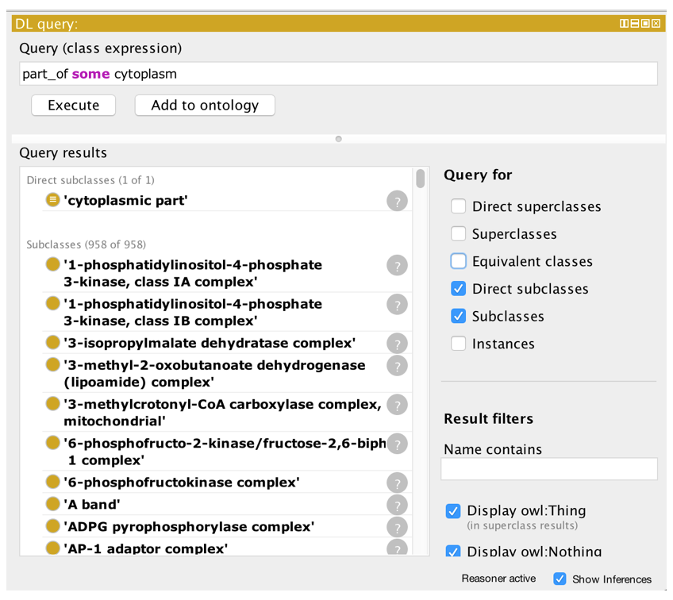
- Find all chromosomes that are part of a cytoplasm
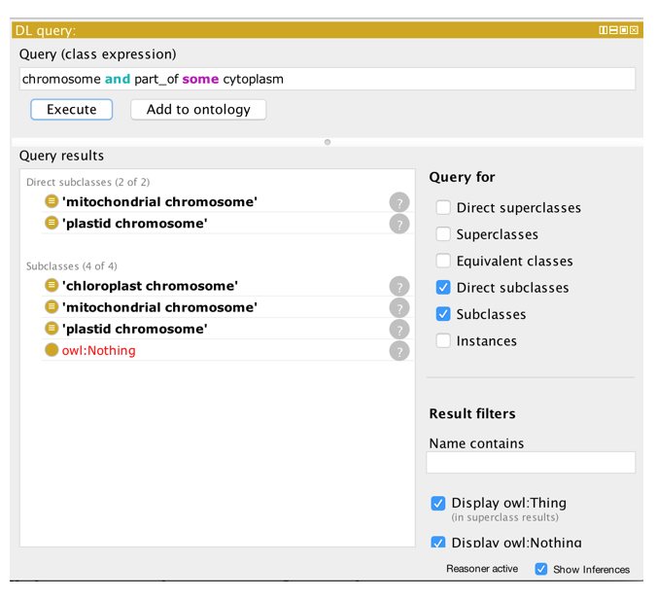
NEXT:
- Find all classes whose instances have a snRNP (‘small nuclear ribonucleoprotein complex’) as part
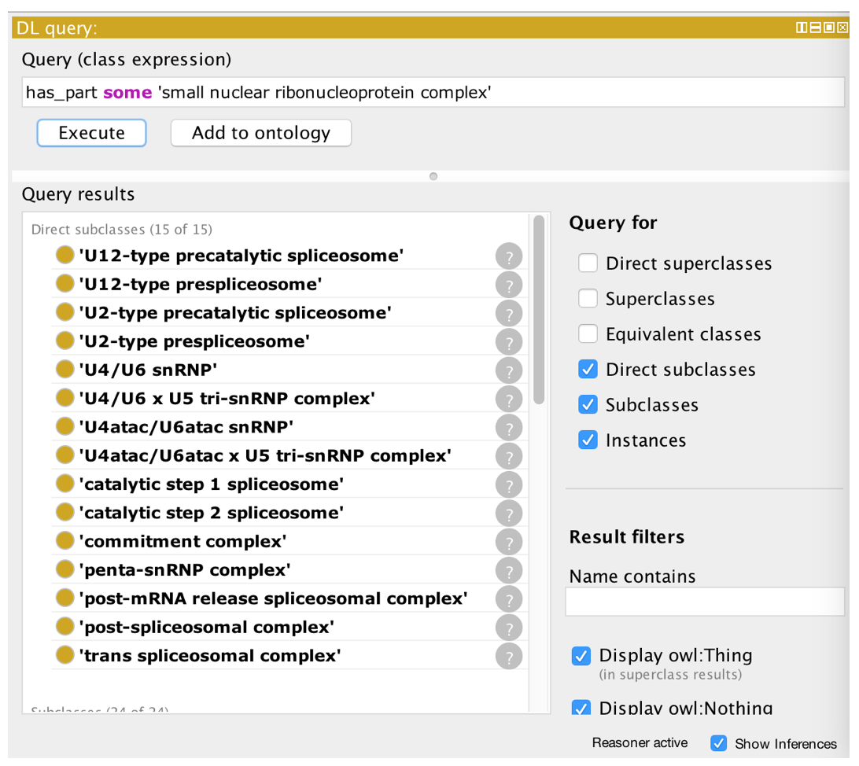
- Find all classes whose instances have both a U11 snRNP AND a U12 snRNP as parts
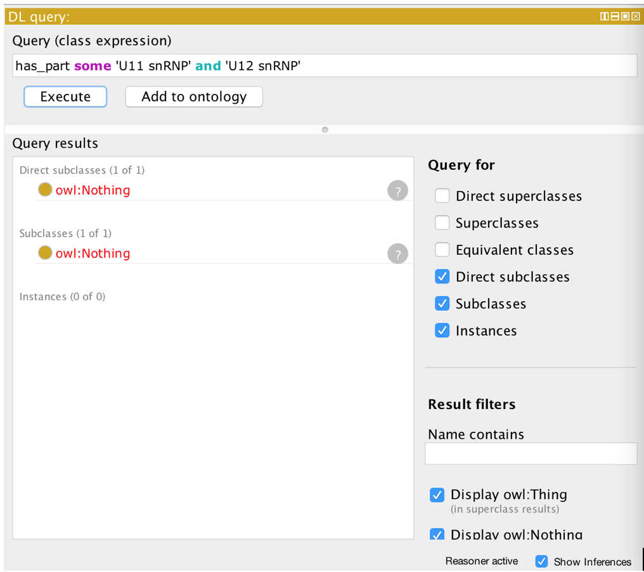
- Find all classes whose instances have both a U11 snRNP OR U12 snRNP as parts
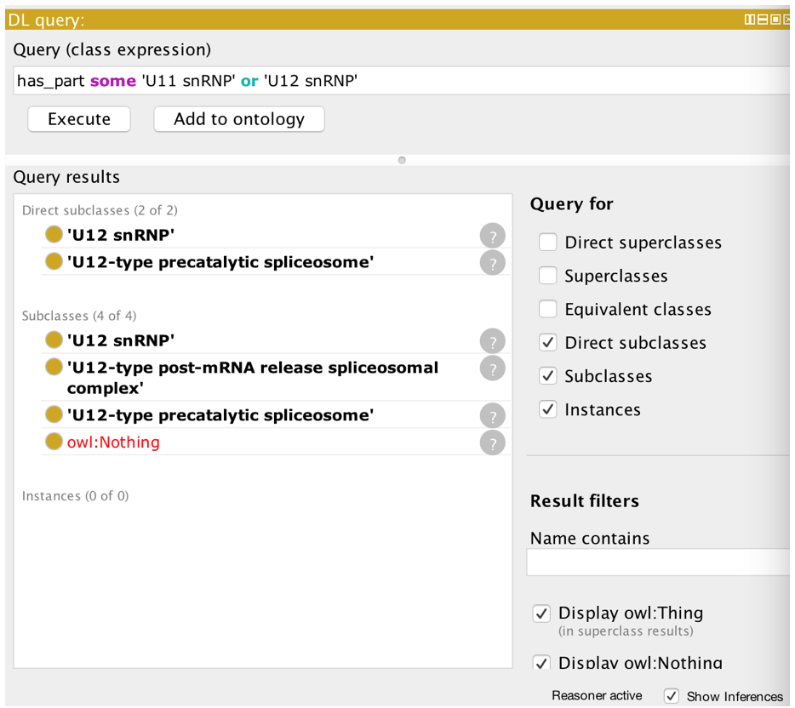
- Create a class from this DL query by clicking the ‘Add to ontology’ button.

Equivalent classes
The previous example showed the creation of a class restriction. These restrictions were asserted as superclass restrictions, and are sometimes known as necessary conditions. That is, if an individual is a member of the ‘cell part’ then it is necessary for it to also be related to a ‘cell’ along the ‘part of’ property.
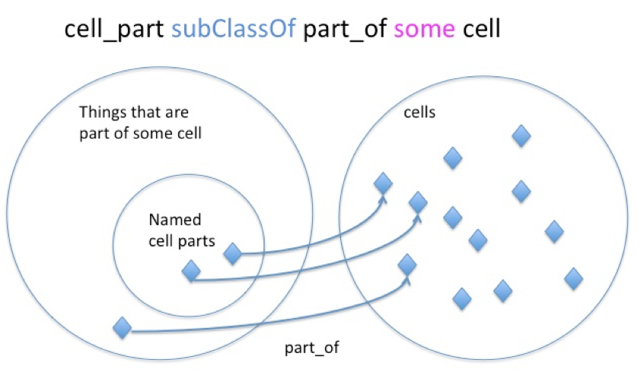
Necessary conditions alone mean that individuals can exist that are part of a cell, but are not a type of ‘cell part’. In OWL, we can make an even stronger statement and define the ‘cell part’ class as being equivalent to ‘part of’ some cell. This is known as a necessary and sufficient condition.
In Protégé we can create an equivalent class restriction inside the ‘Equivalent To’ slot of the class description view.
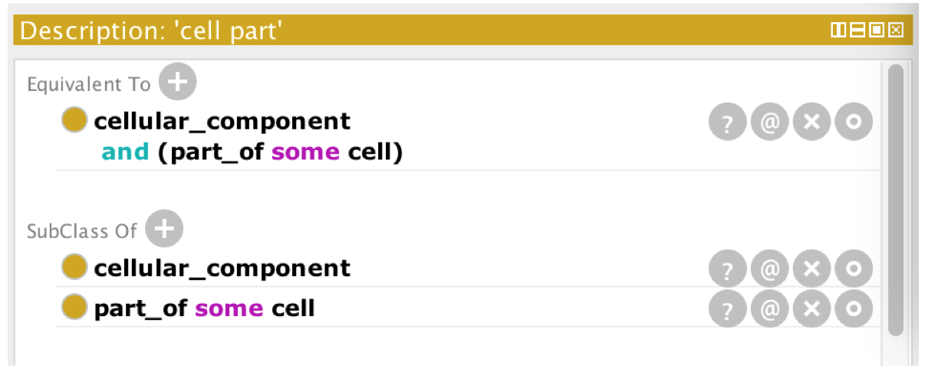

Exercise 2: Create Ontograf results of cc.owl file using protégé.

Solution:

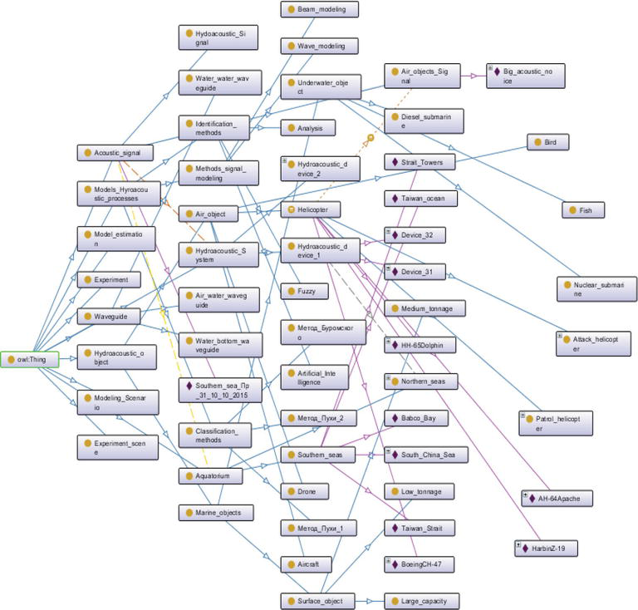

CSE 344 – Semantic Web Lab
Week 14 &15: SPARQL

Learning Objectives:
The objectives of this experiment are:
- Query from ontology and fetch the records.
- Select, where, from clause working having union, intersection
Your lab report is expected to contain the following for each exercise:
- SPARQL Source Code
- Protégé SPARQL structure
- https://www.orpha.net/sparql

Exercise 1: Write given below queries on Ontobee ontology and show the results.

- Find all class-containing ontology graphs
- Find subclasses of an ontology term
- Find the number of all class (or object, annotation, or datatype property) terms of an ontology
- Retrieve definition and authors of all classes in an ontology
- Retrieve general annotations of an ontology
- Query the number of human tRNA genes (OGG_2010009606)
- Count the number of mouse genes associated with mitochondrial DNA repair
- Query on axiom: Find vaccines containing egg protein allergen

Solution:

- PREFIX rdf: <http://www.w3.org/1999/02/22-rdf-syntax-ns#>
PREFIX owl: <http://www.w3.org/2002/07/owl#>
SELECT distinct ?graph_uri
WHERE
{
GRAPH ?graph_uri { ?s rdf:type owl:Class } . }
- PREFIX obo-term: <http://purl.obolibrary.org/obo/>
SELECT DISTINCT ?x ?label
FROM <http://purl.obolibrary.org/obo/merged/OAE>
WHERE
{
?x rdfs:subClassOf obo-term:OAE_0000001.
?x rdfs:label ?label. }

- SELECT count(?s) as ?VO_class_count
FROM <http://purl.obolibrary.org/obo/merged/VO>
WHERE
{
?s a owl:Class .
?s rdfs:label ?label .

FILTER regex( ?s, "VO_" ) }
- OBO IAO ontology annotation terms IAO_0000115 ("definition") and IAO_0000117 ("author") are used.
Below is the SPARQL script:

PREFIX obo-term: <http://purl.obolibrary.org/obo/>
SELECT ?s ?label ?definition ?author
FROM <http://purl.obolibrary.org/obo/merged/VO>
WHERE
{
?s a owl:Class .
?s rdfs:label ?label .
?s obo-term:IAO_0000115 ?definition .
?s obo-term:IAO_0000117 ?author . }
- PREFIX owl: <http://www.w3.org/2002/07/owl#>
SELECT DISTINCT ?p, ?o
FROM <http://purl.obolibrary.org/obo/merged/OAE>
WHERE{
?s a owl:Ontology .
?s ?p ?o .}

- PREFIX obo-term: <http://purl.obolibrary.org/obo/>
SELECT count(DISTINCT ?x) as ?count
FROM <http://purl.obolibrary.org/obo/merged/OGG>
WHERE {
?x rdfs:subClassOf obo-term:OGG_2010009606 .
?x a owl:Class .}
- The number of mouse genes associated with GO 'mitochondrial DNA repair' (GO_0043504). The query fetches the text of the "has GO association" (OGG_0000000029) annotation for each gene from OGG, and then retrieves those genes that have the GO ID "GO_0043504" in their annotation.
Below is the SPARQL script:

PREFIX obo-term: <http://purl.obolibrary.org/obo/>
SELECT count(DISTINCT ?s)
FROM <http://purl.obolibrary.org/obo/merged/OGG-Mm>
FROM <http://purl.obolibrary.org/obo/merged/GO>
WHERE {
#Note: Get OGG-Mm genes associated with GO_0043504
?s a owl:Class .
?s rdfs:label ?labelogg .
?s obo-term:OGG_0000000029 ?annotation .
FILTER regex(?annotation, "GO_0043504") .}
- PREFIX has_vaccine_allergen: <http://purl.obolibrary.org/obo/VO_0000531>
PREFIX chicken_egg_protein_allergen: <http://purl.obolibrary.org/obo/VO_0000912>
SELECT distinct ?vaccine_label ?vaccine
FROM <http://purl.obolibrary.org/obo/merged/VO>
WHERE {
?vaccine rdfs:label ?vaccine_label .
?vaccine rdfs:subClassOf ?vaccine_restriction .
?vaccine_restriction owl:onProperty has_vaccine_allergen:; owl:someValuesFrom chicken_egg_protein_allergen: .
}

Exercise 2: Write the SPARQL queries and show the results.

- Return all the classes and the attached properties from the ontology
- Find value from properties of an instance of a subclass
- Find the objects of the individuals
- In which subject and object this property lies
- The SPARQL keyword a is a shortcut for the common predicate rdf:type, giving the class of a resource. List all classes in a dataset with type
- It is defining the subclass, individual and value
- Query showing all the domain characteristics
- UNION OF
- Filter
- Synonyms Property

Solution:

The query return all the classes and the attached properties from the ontology
SELECT ?subject ?object
WHERE {?subject rdfs:subClassOf ?object}
ORDER BY ?subject
OR
SELECT ?subject ?object
WHERE { ?subject rdfs:subClassOf ?object }

Find value from properties of an instance of a subclass
SELECT ?object
WHERE {<http://www.owl-ontologies.com/OntologyfeeCIIT.owl#BSArchitecture_DDP>
<http://www.owl-ontologies.com/OntologyfeeCIIT.owl#hasLaboratoryFee>
?object}
=====================================================================================
Find the objects of the individuals
SELECT ?subject ?object
WHERE { <http://www.owl-ontologies.com/OntologyfeeCIIT.owl#BSArchitecture_DDP> <http://www.owl-ontologies.com/OntologyfeeCIIT.owl#hasPreRequsite>
?object}
In which subject and object this property lies
SELECT ?subject ?object
WHERE { ?subject <http://www.owl-ontologies.com/OntologyfeeCIIT.owl#hasPreRequsite>

?object}
The SPARQL keyword a is a shortcut for the common predicate rdf:type, giving the class of a resource. List all classes in a dataset with type
PREFIX rdf: <http://www.owl-ontologies.com/OntologyfeeCIIT.owl#>
SELECT DISTINCT ?type
WHERE {
?s a ?type.
}

It is defining the subclass, individual and value
SELECT ?x ?y ?z
WHERE {?y CUSTnew:hasAdmissionFee ?x.
?y rdf:type ?z
}
ORDER BY ?object

Query showing all the domain characteristics
SELECT ?x ?y
WHERE {?x rdfs:domain ?y.}

UNION OF (Domain and members of)
PREFIX Comsats: <http://www.semanticweb.org/ontologies/2012/2/CUSTnew.owl#>
PREFIX rdfs: <http://www.w3.org/2000/01/rdf-schema#>
Prefix owl:<http://www.w3.org/2002/07/owl#>
Prefix list:<http://jena.hpl.hp.com/ARQ/list#>
SELECT distinct ?x ?m WHERE { ?x rdfs:domain ?s. ?s owl:unionOf ?l. ?l list:member ?m. }

UNION OF
PREFIX Comsats: <http://www.semanticweb.org/ontologies/2012/2/CUSTnew.owl#>
PREFIX rdfs: <http://www.w3.org/2000/01/rdf-schema#>
Prefix owl:<http://www.w3.org/2002/07/owl#>
Prefix list:<http://jena.hpl.hp.com/ARQ/list#>
SELECT distinct ?x ?y
WHERE {?x <http://www.w3.org/2000/01/rdf-schema#domain> ?y.
?y <http://www.w3.org/2002/07/owl#unionOf> ?z }
order by ?y

Filter
PREFIX Comsats: <http://www.semanticweb.org/ontologies/2012/2/CUSTnew.owl#>
PREFIX rdfs: <http://www.w3.org/2000/01/rdf-schema#>
Prefix owl:<http://www.w3.org/2002/07/owl#>
Prefix list:<http://jena.hpl.hp.com/ARQ/list#>
SELECT DISTINCT *
WHERE {
?x Program:BS ?y .
{
OPTIONAL {
?y a ?type .
} FILTER ( ! BOUND ( ?type ) )
} UNION {
?y a Program:SomeType .
}
}

Synonyms Property
SELECT ?x ?y ?z
WHERE {?y CUSTnew:hasSynonyms "DDP".
?y rdf:type ?z
}
ORDER BY ?object
……….
SELECT ?x ?y ?z
WHERE {?y CUSTnew:hasSynonyms ?x.
?y rdf:type ?z
}
ORDER BY ?object

THE END

